


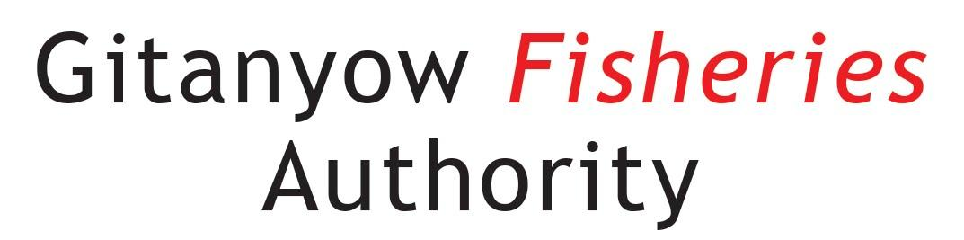
Collaborative Monitoring as a Component of Sockeye Recovery – Kitwanga River – Gitanyow Lax’yip

Report Prepared By:

Kevin Koch – BSc., RPBio
Fish and Wildlife Biologist
Mark Cleveland - BSc., RPBio
Head Fisheries Biologist
Gitanyow Fisheries Authority
Gitanyow Hereditary Chiefs
PO Box 397
Kitwanga, BC V0J 2A0

Report Prepared For:

Glen Buhr, RPF
Stewardship Officer
B.C. Ministry of Forests, Lands, Natural Resource Operations and Rural Development
Resource Planning and Assessment Branch
PO Box 9525
STN PROV GOVT
Victoria, B.C.
V8W 9N1

DATE – April 16, 2021

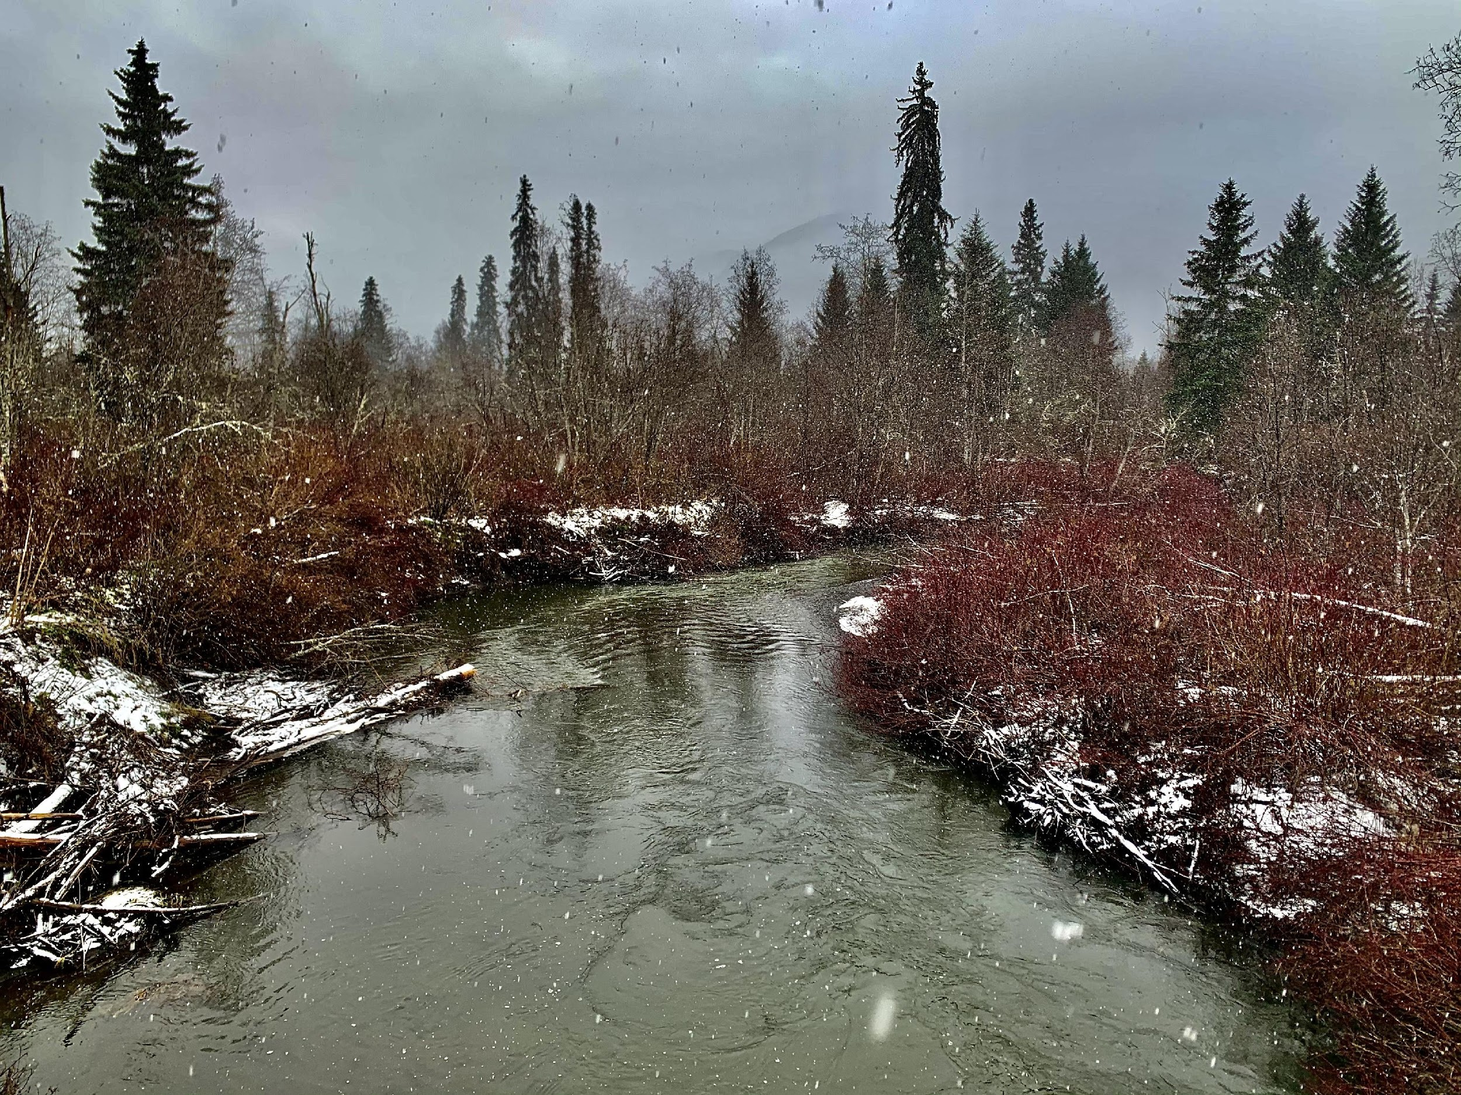

Acknowledgements

This project was made possible through funding from the B.C. Ministry of Forests, Lands, Natural Resource Operations and Rural Development. Gitanyow Chiefs Gwaas Hlaam and Gwinuu allowed us to do this work on their Wilp territories. Many people collaborated on the project, including Mark Cleveland, Tara Marsden, Joel Starlund, Kevin Koch for project management and senior oversight. James Morgan, Greg Johnson, Dustin Gray and Les McLean assisted with fieldwork. Consultants Jeffrey Anderson, Mike McCarthy and Marilyn Freel contributed expertise to the project. Glen Buhr, Dave Wilford, Matt Sakals and Jesse Fraser brought various expertise and experience to the project.

Table of Contents

Introduction 5
Project Objectives 10
Objective 1 – Assess FSC and Commercial/Economic Fishing Need 10
Objective 2 – Compilation of Existing Kitwanga Watershed Habitat Data 10
Objective 3 – Ground Based Monitoring Plan 10
Objective 4 – Recommended Next Steps 11
Methods 12
Project Team 12
Scope of Study 12
Methods - Objective 1: Socio Cultural Assessment 13
Methods - Objective 2: Data Compilation 13
Methods - Objective 3: Ground Based Technical Assessment - Methods 13
Modified CABIN-eDNA 13
Hydrometric Infrastructure Development 14
2020 Hydrometric Station Installations 14
2020 Tidbit Datalogger Installations 17
2020 FREP-ESI Wetland Assessments 21
Methods - Objective 4: Recommendations for Next Steps 21
Results and Discussion 21
Objective 1: Socio-Cultural Assessment 21
First Nations Traditional Use 21
Historical Salmon Abundance 23
Kitwanga Sockeye 24
Kitwanga Chinook 28
Kitwanga Coho 28
Kitwanga Steelhead 28
Objective 2: Data Compilation 28
Objective 3: Ground Based Technical Assessment 29
CABIN-eDNA Sampling 29
Wetland Sampling 29
Hydrometric Station Development and Tidbit Installations 29
Objective 4: Recommendations for Next Steps 29
References 30

List of Figures

Figure 1: Map of Gitanyow Lax’yip (Traditional Territory). 3
Figure 2: CABIN/eDNA sites, Tidbit installation locations and new hydrometric station locations - Kitwanga River Watershed (2020-21). 12
Figure 3: Map of historical Kitwanga sockeye spawning locations. 19

List of Tables

Table 1: Hydrometric stations established in the Kitwanga River in 2020 8
Table 2: General methods used for configuration and installation of HM2, HM3 & HM4 in 2020. 9
Table 3: Intended Tidbit installation locations for spring 2021. 11

List of Photos

Photo 1: T’in (fish fence) photographed by federal fisheries inspector Louis Shotridge directly below Gitanyow village in 1918 (Courtesy of the Canadian Museum of Civilization, 71-8442). 14
Photo 2: A T'in (fishing weir) on the Kitwanga River in 1945, located ~2km downstream of Gitanyow Lake. Federal Research Board of Canada (Rabnett et al., 2002). 15
Photo 3: Fisheries officers Fisher (left) removing a dead sockeye from net and McConnell (right) releasing a live sockeye – Gitanyow Lake (1946). 17

Introduction
The Kitwanga River is a tributary of the Skeena River located approximately 250km inland from the Pacific Ocean. A relatively small, but biologically rich river, the Kitwanga supports populations of all five species of Pacific salmon, as well as steelhead salmon, rainbow, cutthroat and bull trout, Dolly Varden char, kokanee salmon and numerous coarse fish species. These fish communities form a valuable part of the local ecosystem. Anadromous (ocean going) salmon in particular form a valuable and vital source of food and nutrients for the Kitwanga Watershed and support an abundant flora and fauna and very high biodiversity values.

Kitwanga salmon (Oncorhynchus spp.) continue to be an extremely important Food, Social and Ceremonial (FSC) source for the First Nations people that inhabit the area. The Kitwanga River in particular was important from a cultural and economic standpoint and fished annually by the Gitanyow that inhabited the watershed. Most of the Kitwanga River is within the Gitanyow Lax Yip (traditional territory) and subsequently there is a long oral and more recently written history of Gitanyow fishing presence on the river. Historically the Gitanyow would operate well established T’ins (weirs) on the Kitwanga River to harvest a portion of the annual salmon returns.

A variety of industries and anthropogenic factors have played a role in impacting Kitwanga River fish and fish habitat values. Kitwanga salmon have and continue to be harvested in commercial marine mixed-stock fisheries in DFO stat areas 3-5 and by the Alaskan’s in US waters. Kitwanga sockeye in particular have been impacted the most from these fisheries. Fishing impacts on Kitwanga Chinook and coho salmon have also likely been significant over time, but impacts on these stocks are less well understood.

A large portion of the Kitwanga Watershed was logged in the 1960’s and 1970’s (Figure 1). Forest harvesting impacts have and continue to have significant negative effects on fish and fish habitats in the watershed. Fish passage, water quality (including temperature) and hydrological flow regimes in particular are believed to be much different now then they once were prior to logging and this has prompted extensive assessment and in some cases remediation works. Highway 37 also bisects the watershed which has resulted in linear watershed level effects and significant fish passage and water flow issues.

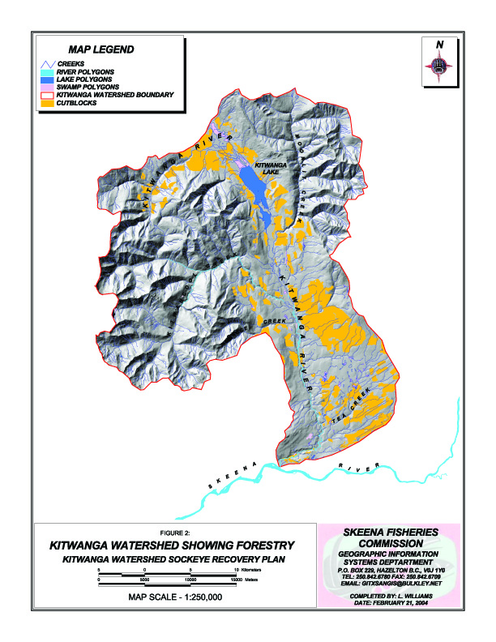
Figure 1: Kitwanga River watershed, logging cutblocks as of WHAT DATE?

These historic and ongoing industrial stressors combined with the uncertainty of climate change, has prompted the Gitanyow and government officials to undertake a comprehensive needs assessment for the Kitwanga. The salmon runs in particular are all suffering because of a large variety of known and potentially yet unknown causes and currently salmon returns are a small fraction of their historical abundance. Because the Kitwanga watershed is very valuable from a socio-cultural and ecological perspective, and because salmon runs, especially sockeye, have reached dangerously low levels, the Gitanyow Hereditary Chiefs (GHC) through their technical arm, the Gitanyow Fisheries Authority (GFA) have developed and have been implementing a Kitwanga Sockeye Recovery Program (KSRP) over 20 years ago.

This multi-million dollar program has resulted in the establishment of two state-of-the-art fish counting facilities (one for adults, one for smolts), extensive limnology work on Gitanyow (Kitwancool) Lake, temporary hatchery production of sockeye, hundreds of forestry road crossing assessments and numerous road deactivations. Ongoing beaver dam mitigation targeted at forestry road crossing locations and on the mainstem of the Kitwanga River where they can become problems to fish passage have also been the focus of intense work. The development and ongoing refinement of the KSRP has involved dozens of scientists and other experts from First Nations organizations, the Department of Fisheries and Oceans, Canada (DFO), the Ministry of Forests, Lands and Natural Resource Operations and Rural Development (FLNRORD), non-governmental organizations such as SkeenaWild, universities and most importantly, Gitanyow Chiefs, elders and knowledge holders.

The project being reported on herein originated through the Gitanyow’s involvement in the Environmental Stewardship Initiative (ESI) and because of our ongoing relationship with the B.C. government through FLNRORD and their Forest and Range Evaluation Program (FREP), under which we have done extensive training and project implementation. The ESI project is tasked with developing new and improved monitoring and assessment programs and may result in the transitioning, in some cases, of the FREP program. Hence, as this project served to bring together elements of both programs it was termed the FREP-ESI project and was designed to initiate a process to address certain monitoring and assessment needs that could serve to inform the broader KSRP and overall watershed restoration approaches.

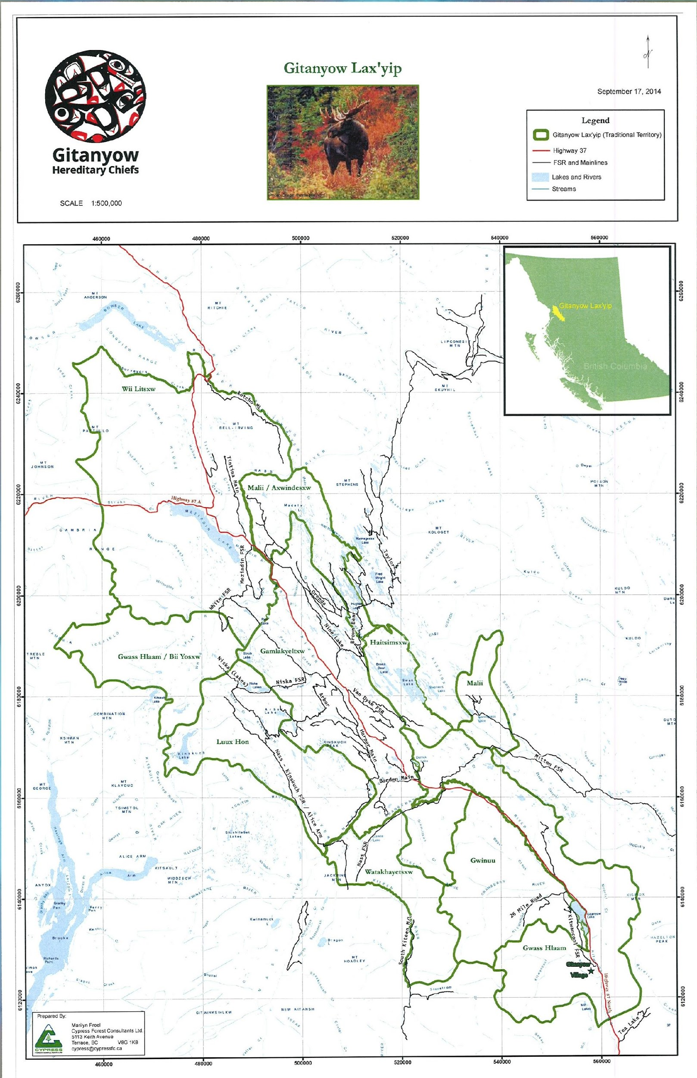

Project Objectives

Objective 1 – Assess FSC and Commercial/Economic Fishing Need
This objective is intended to provide an assessment of current and projected Gitanyow Wilp FSC and commercial fishing needs with respect to Kitwanga salmon stocks and to develop long-term monitoring indicators and thresholds for this objective.

Objective 2 – Compilation of Existing Kitwanga Watershed Habitat Data

GFA has collected a significant amount of habitat related information over the last two decades. A key component of this project was to compile that information and provide it in an accessible location and format so that it can be a benefit to the broader community of resource practitioners. GFA staff collaborated with FLNRORD staff (primarily Jesse Fraser) to upload this information to the Sync drive currently being utilized as a sharing platform for the ESI project.

The intent of this is to use this location to upload information regarding the Kitwanga Watershed on a continuous basis.

Objective 3 – Ground Based Monitoring Plan
The intent of Objective 3 is to collaboratively design and begin implementation of a spatially-defined watershed-level monitoring plan that is:
- Consistent with the ESI Tiered Fish Habitat Monitoring Approach.
- Facilitates understanding of the factors affecting stream-reach level fish health and spawning/rearing success with a focus on a frequent de-watering event occurring on the Kitwanga River between Moonlit Creek and Gitanyow Lake which has negatively impacted migrating sockeye salmon.
- Includes the co-selection of Tier 2 monitoring indicators and pertinent monitoring protocols that are reasonably consistent with options recommended in the February 2019 Skeena ESI Fish Habitat Assessment Procedure.

Monitoring that could be included under this contract include:
- Annual snow depth monitoring;
- Wetland assessments (ESI and FREP protocols);
- CABIN/eDNA sampling;
- Environmental Flow Needs analysis;
- Hydrometric station development.

The following governmental support/resourcing was intended to be provided towards Objective 3:
- Creation of a base map series supporting monitoring plan design.
- Collaboration on monitoring plan design.
- Collaborative delivery of certain Tier 2 assessments, subject to staff availability.

Objective 4 – Recommended Next Steps
To produce a list of recommended next steps required to achieve the overarching Pilot Project goal, including cost estimates. These could include but not be limited to:

- New data/existing data layer improvement recommendations towards next iteration of Tier 1 GIS analysis and support to Continuous Improvement cycle.
- Recommended works.
- Recommended linkages to other projects.

Methods

Project Team

The Project Team (PT) consists of staff from the Gitanyow Hereditary Chiefs (GHC) / Gitanyow Fisheries Authority (GFA) and the B.C. Ministry of Forests, Lands, Natural Resource Operations and Rural Development (FLNRORD).

Team Member | Organization | Task
Glen Buhr | FLNRORD | - Project lead for FLNRORD  - Involved in all project phases
Todd Bresser | FLNRORD | - District field lead – participant in all phases
Leah Malkinson | FLNRORD | - Project sponsor – spending authority
Lisa Nordin | FLNRORD | - Phase 3 – monitoring plan design
Lars Reese-Hanson | FLNRORD | - Phase 3 – monitoring plan design
Don Morgan | BC Ministry of Environment | - Phase 3 – monitoring plan design, field monitoring
Dave Wilford | FLNRORD | - Phase 3 – monitoring plan design
Matt Sakals | FLNRORD | - Phase 3 – drone-photo acquisition
Brian MacDonald | FLNRORD | - Phase 3 – drone-photo acquisition
Jesse Fraser | FLNRORD | - Phase 3 – Tier One GIS analysis advice; data governance solutions
Mark Cleveland | GFA | - Project Supervisor – involved in all phases.
Kevin Koch | GFA | - All phases – project planning, fieldwork, reporting.
Tara Marsden | GHC | - Phase 1 lead
Joel Starlund | GHC | - Phase 1 participant
James Morgan, Greg Johnson, Dustin Gray, Les McLean | GFA | - Phase 3 – field work
Jeffrey Anderson | Geomorphic Consulting | - Phase 3 – planning and field work  - Phase 4 – assisting in drafting recommendations
Mike McCarthy | Kam River Consulting | - Phase 2 – data compilation  - Phase 3 – fieldwork and reporting  - Phase 4 – assisting in drafting recommendations
Marilyn Freel | Cypress Forest Consultants | - Phase 2 – assisting in data compilation  - Phase 3 – GIS services

Scope of Study

This study is focussed geographically on the Kitwanga Watershed, which is located in the middle Skeena River in northwestern B.C. (Figure 1). The Kitwanga Watershed falls within the Gitanyow Wilp territories of Gwinuu and Gwaas Hlaam.

This study is part of a much broader sockeye restoration program initiated by Gitanyow in the early 2000’s. The study was designed to first gain a better understanding of the historical uses and needs of the Gitanyow people in relation to Kitwanga sockeye, and second to gain insight into flow and temperature related issues in and around Gitanyow Lake and their relation to migrating and spawning sockeye salmon.

Methods - Objective 1: Socio Cultural Assessment

The intention for this objective was to conduct meetings with Wilps Gwinuu and Gwaas Hlaam, however this was not possible due to the Covid-19 pandemic. Instead, an internal literature review was conducted with a focus on historical:

- FSC use of Kitwanga salmon;
- spawning distribution of Kitwanga sockeye;
- escapements and spawning ground counts of Kitwanga sockeye.

Wilp membership for wilps Gwinuu and Gwaas Hlaam were obtained from internal GHC records.

Methods - Objective 2: Data Compilation

A literature review was conducted for reports, data and spatial files relating to the Kitwanga watershed with a focus on habitat. Files were organized into folders by year and were uploaded to a Sync folder accessible to FLNRORD staff.

Methods - Objective 3: Ground Based Technical Assessment - Methods

Modified CABIN-eDNA
Field crews followed the Environment Canada field manual for wadeable streams (2012 - http://publications.gc.ca/collections/collection_2012/ec/En84-87-2012-eng.pdf) with one modification. Instead of collecting invertebrate samples for traditional taxonomic analysis, the invertebrate samples were collected for eDNA analysis. The reasons for this change were two-fold:

- Sampling started late for several reasons including consistent high water and a shortage of preservative supply for eDNA sampling, putting us later than the window where it is biologically appropriate to collect samples for taxonomy (mid-September is approximately the latest for taxonomic collection). When collecting samples for eDNA analysis, sampling can occur anytime the stream is accessible.
- Because of our collaboration in 2020 with the STREAM network we were able to get eDNA sampling covered for free which saved us approximately $400 per site for taxonomic analysis.

Field crews completed all other aspects of the CABIN protocol and filled out the CABIN field form as shown in Appendix 1 (App1A-eDNA_CABIN_field_sheet). Collection of eDNA samples followed the protocol outlined in Appendix 1 (App1B-eDNA_CABIN_sample_collection_guidelines). Equipment and supplies used generally followed the equipment/supplies list shown in Appendix 1 (App1C-CABIN_Kit_updated). These documents were all provided as part of a training course provided by Living Lakes Canada in conjunction with ESI and the STREAM network.

The field crew had two CABIN certified crew leaders and two technicians that were certified CABIN technicians. Five sites were completed in the Kitwanga Watershed in 2020 which add to the two completed in 2019 through a separate project (Figure 2).

Hydrometric Infrastructure Development
After consulting with Dr. Dave Wilford and Glen Buhr in the field on October 9, 2020 to discuss the hydrological monitoring strategy for the Kitwanga, it was decided to install three hydrometric stations and at least 10 Tidbit dataloggers in the Kitwanga Watershed (Figure 2, Table 1, Table 2).

2020 Hydrometric Station Installations
The strategy for installation of the four hydrometric stations in the Kitwanga in 2020 followed on the objectives for their development, which included:

- HM1 (adult fence) – to develop long-term monitoring of stage-discharge relationships at the furthest feasible downstream location. In 2020 there was an immediate need to calibrate eDNA sampling of adult salmon eDNA with stream discharge. However, because of the extremely high value of Kitwanga salmon the Kitwanga is a high priority for developing an accurate stage-discharge relationship. This will aid in future EFN assessments, synthetic hydrograph developments, correlations of salmon migrations with discharge, drought management and other needs.
- HM2 (smolt fence) & HM3 (26-Mile) – To gain understanding of conditions in Kitwanga Lake for spawning sockeye and rearing for sockeye, coho and several other salmonid species, developing stage-discharge records for the largest inlet stream and the outlet stream for Kitwanga was prioritized. Although there are at least 18 inlet streams to Kitwanga Lake, the upper Kitwanga River is the largest.
- HM4 (Gitanyow Lake) – This station was developed to monitor lake levels over time and to correlate lake levels with inlet and outlet discharge, and discharge downstream at the adult fence.
Table 1: Hydrometric stations established in the Kitwanga River in 2020
Hydrometric station # | Local ID/Map label | UTM Zone | UTM E | UTM N | Date installed | Location description | Logger Type | Comments
1 | HM1 | 9U | 560642 | 6108218 | July 2020 | Kitwanga salmon enumeration facility | Two Solinst Leveloggers and one Barologger | Funded through separate project.
2 | HM2 | 9U | 556999 | 6131602 | Dec 2020 | ~100 DS of Kitwanga smolt fence | Solinst Levelvent logger | Funded through FREP-ESI and Federal Guardians program
3 | HM3 | 9U | 555974 | 6136641 | Nov 2020 | largest island in north basin of Gitanyow Lake | Solinst Levelogger | Funded through FREP-ESI and Federal Guardians program
4 | HM4 | 9U | 553219 | 6141235 | Nov 2020 | 26-mile FSR bridge at 0.15 km from hwy 37 | Solinst Levelvent logger | Funded through FREP-ESI and Federal Guardians program

Three different types of loggers are installed in the Kitwanga watershed, however they work similarly. HM1 (adult fence location) has two Solinst Leveloggers and a Solinst Barologger. These units work in conjunction to determine water level at the loggers. HM3 (lake location) has one Solinst Levelogger which also works in conjunction with the Barologger at HM1 to determine water level at the logger. HM2 (smolt fence location) and HM4 (26-Mile FSR location) both have LevelVent 5 Level Loggers. These are standalone units that have a built in barometric logger, therefore a single LevelVent logger negates the need for a separate Levelogger/Barologger system. We use both configurations in our overall hydrometric program.

The LevelVent, Levelogger and Barologger systems all have a pressure transducer and a temperature sensor. The LevelVents and Leveloggers record water temperature and the Barologgers record air temperature. All systems record barometric pressure. The LevelVents record water pressure but also have a breather tube that records atmospheric pressure and allows for a real time atmospheric correction (water pressure – atmospheric pressure). The Leveloggers record water pressure and the Barologgers record atmospheric pressure. The Solinst software takes water pressure data and compensates for the atmospheric pressure data to calculate water level in whatever units are chosen.

h=(P-Pr)/(rho*g)
h=water level
P=pressure measured in stream
Pr=pressure measured in air/atmosphere
rho=density of water in stream
g=acceleration due to gravity

The LevelVent and Leveloggers have 120,000 and 150,000 point memories respectively. All loggers were set to record at 10 minute intervals which gives a very high resolution. The LevelVents and Leveloggers could record for 833 days and the 1041 days respectively without being downloaded, however we typically download all loggers a minimum of twice per year to minimize lost data in the event of logger damage/malfunction.

The same general installation method was used at HM2, HM3 and HM4. Starting from the logger sensor end of the system to the connection port end of the system, the installation components/configuration were as follows:

Table 2: General methods used for configuration and installation of HM2, HM3 & HM4 in 2020.
LevelVent loggers at HM2 & HM4 connected to a 15 foot vented cable assembly (HM2 & HM4) | 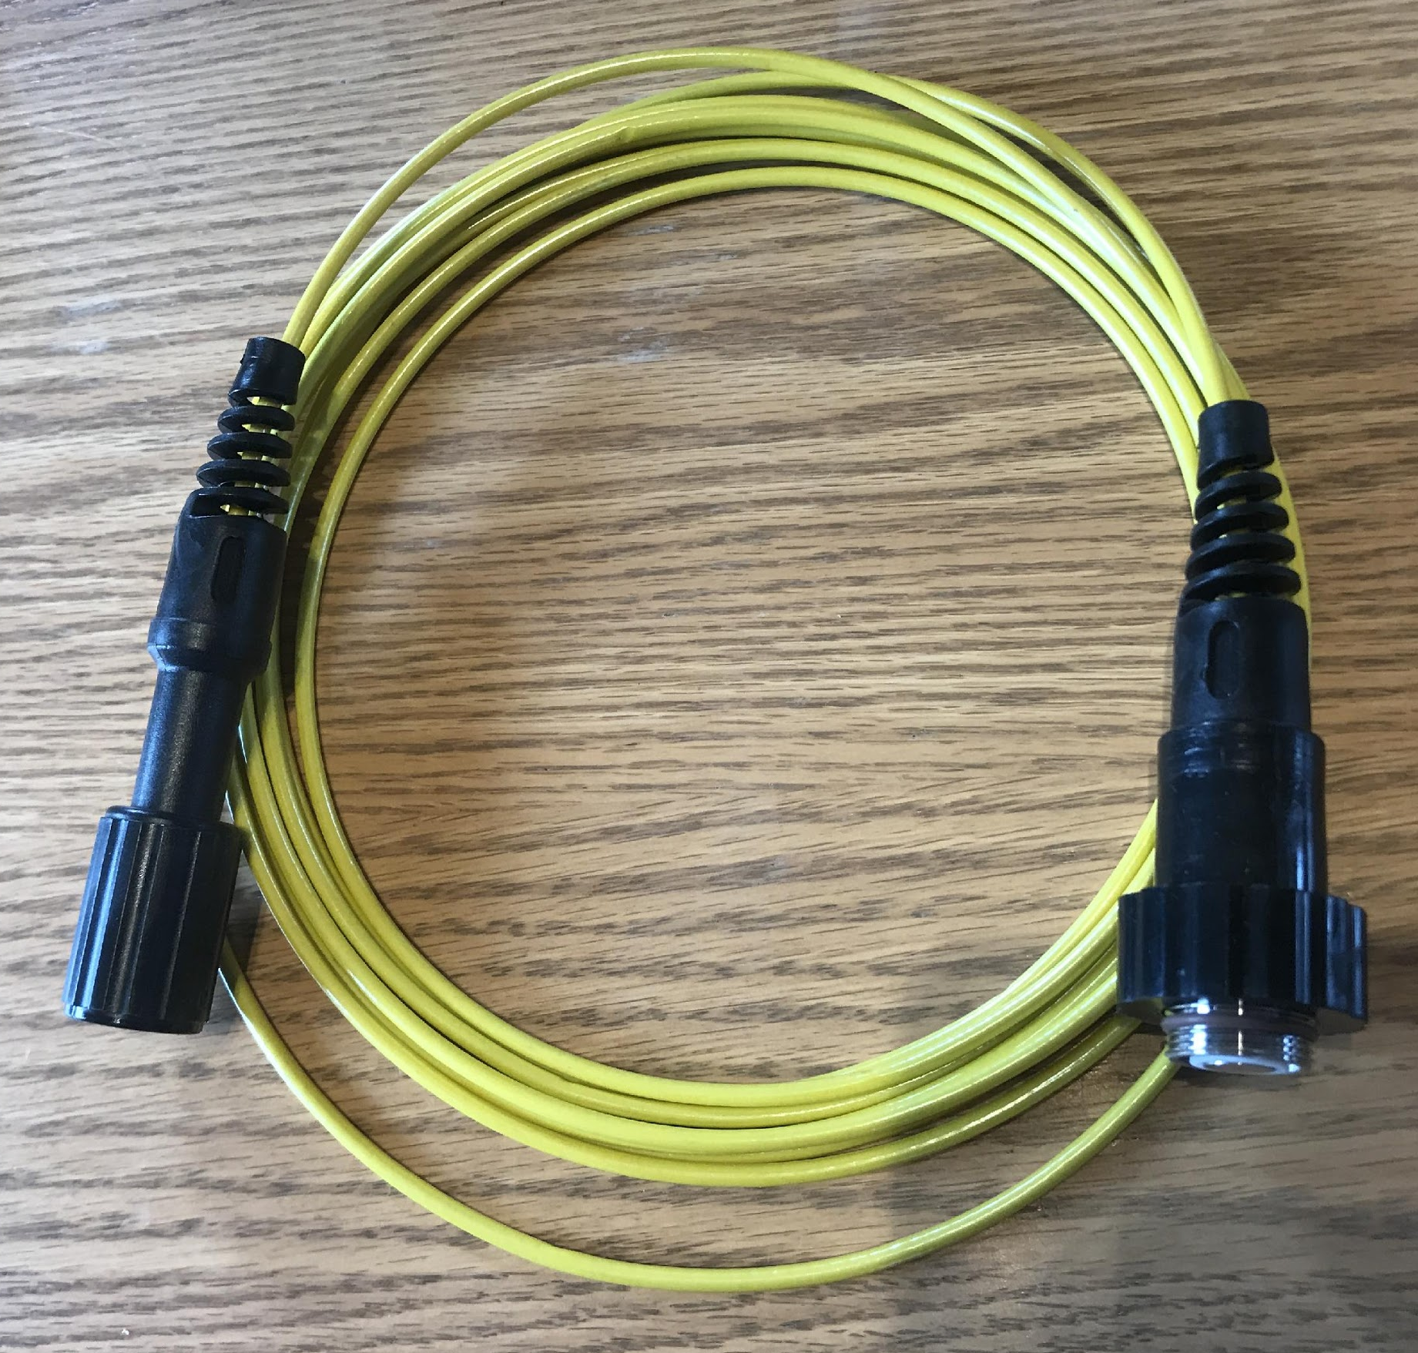
Levelogger at HM 3 connected to a 50 foot direct read cable assembly (HM3)
Both LevelVent and Leveloggers secured inside 1.5” electrical conduit | 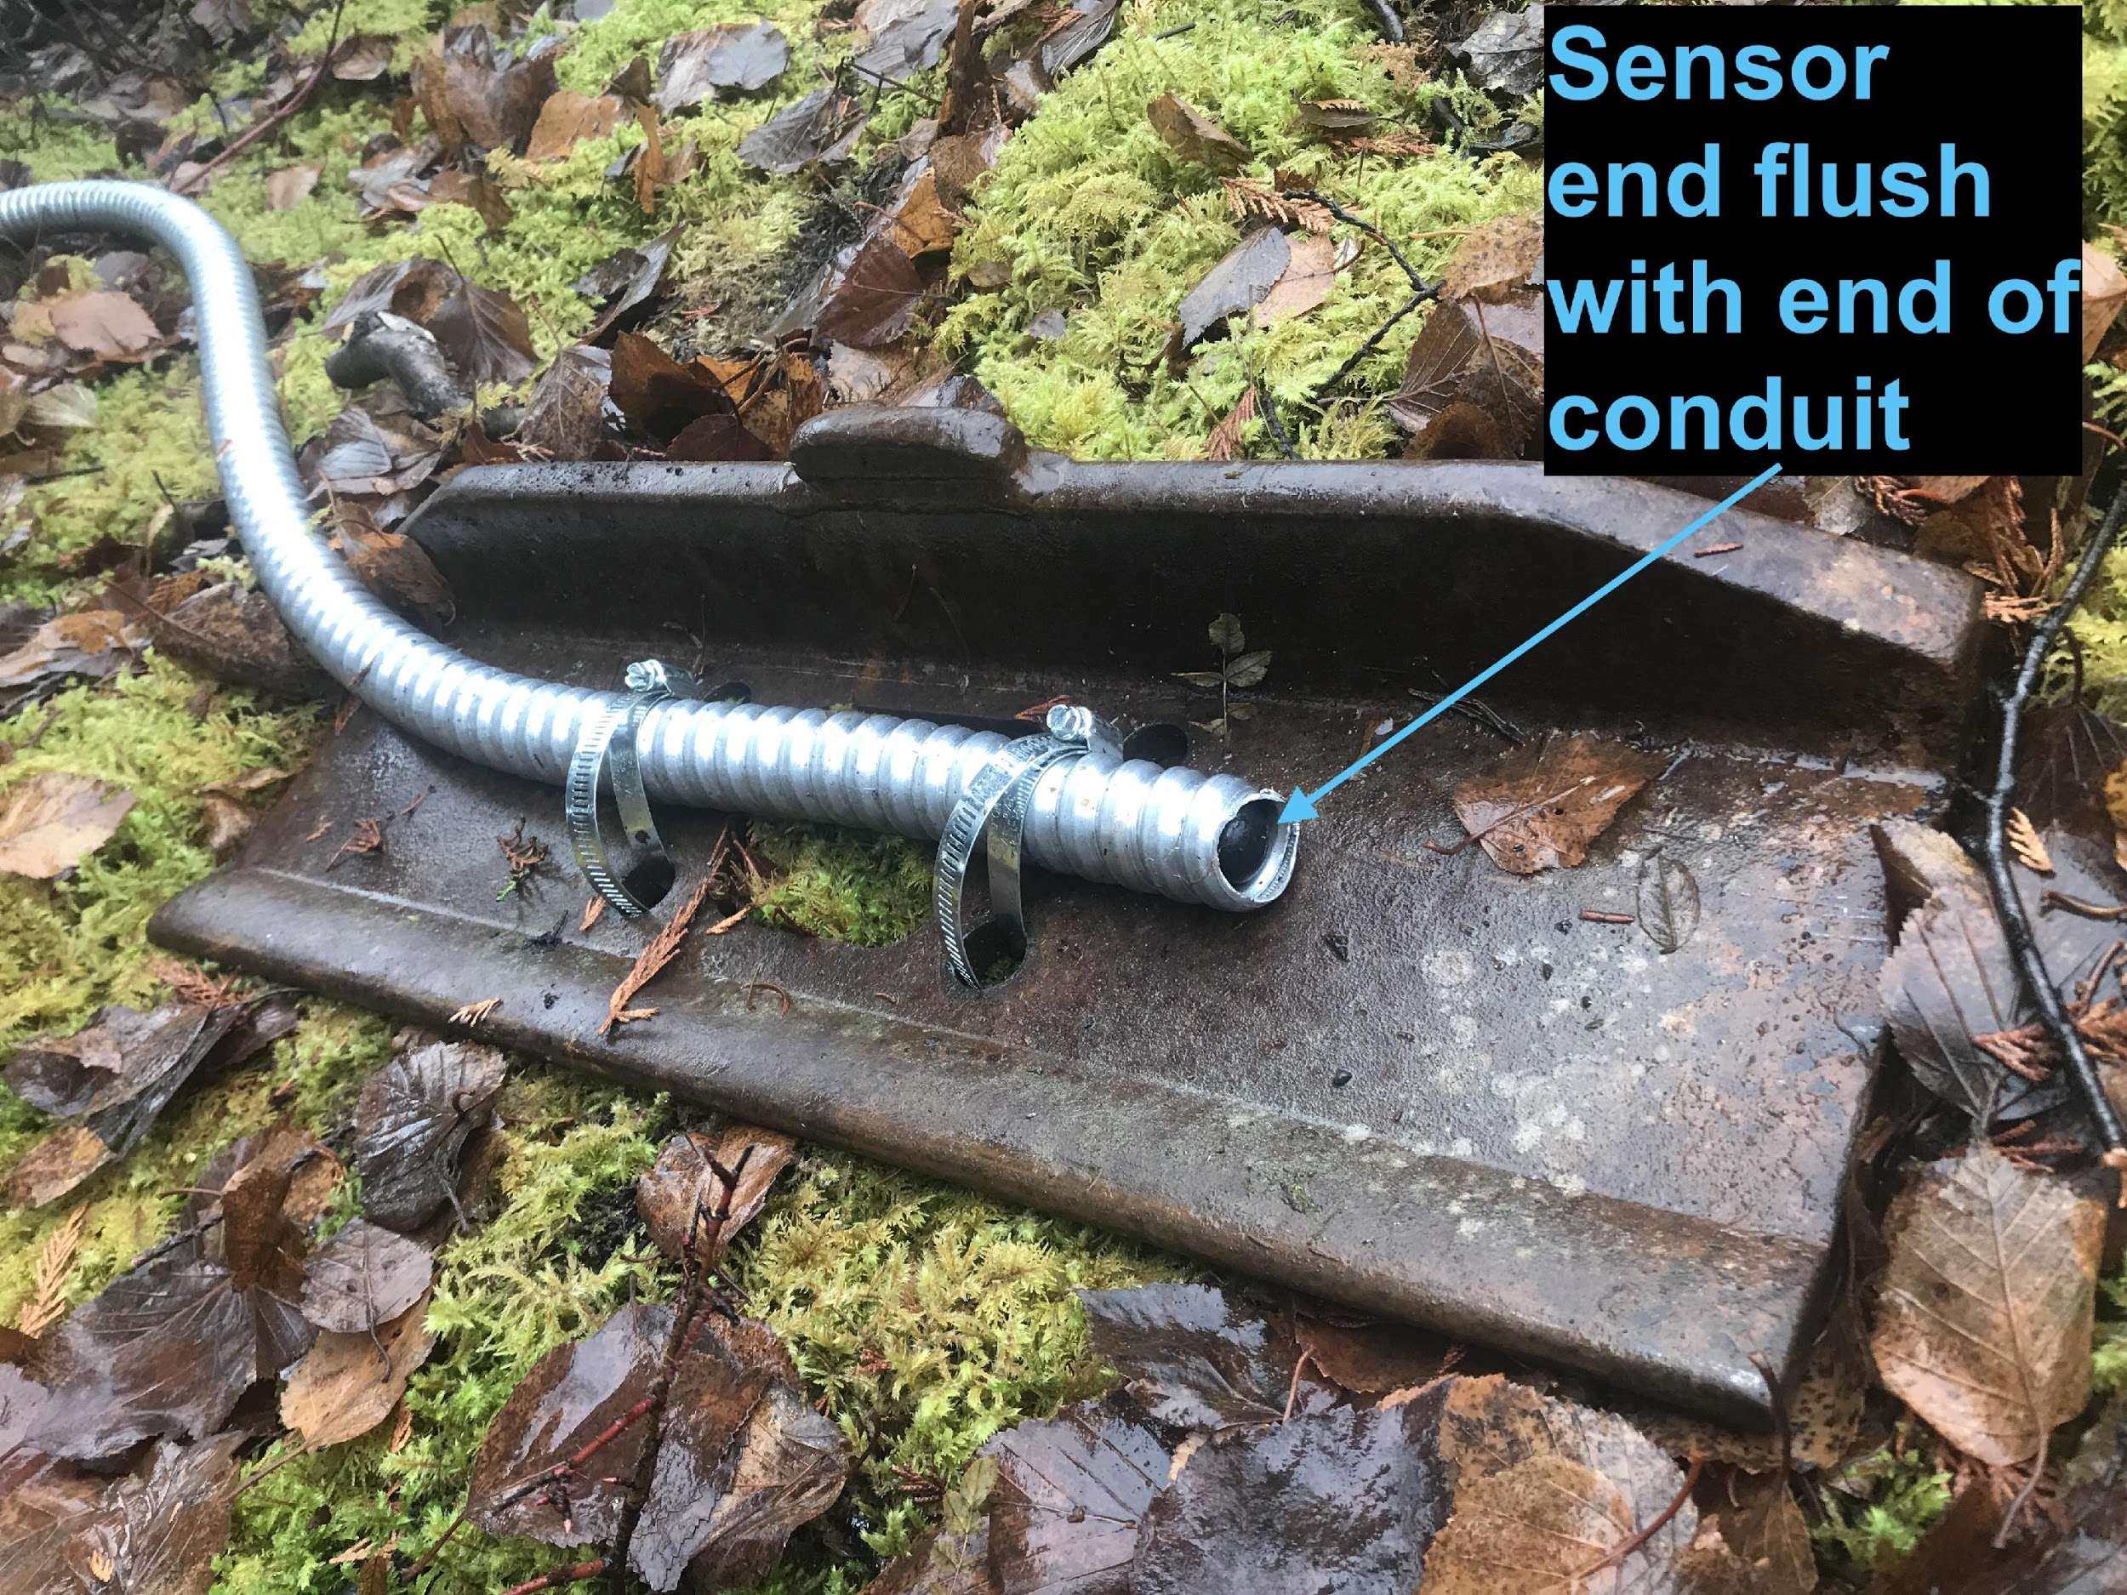  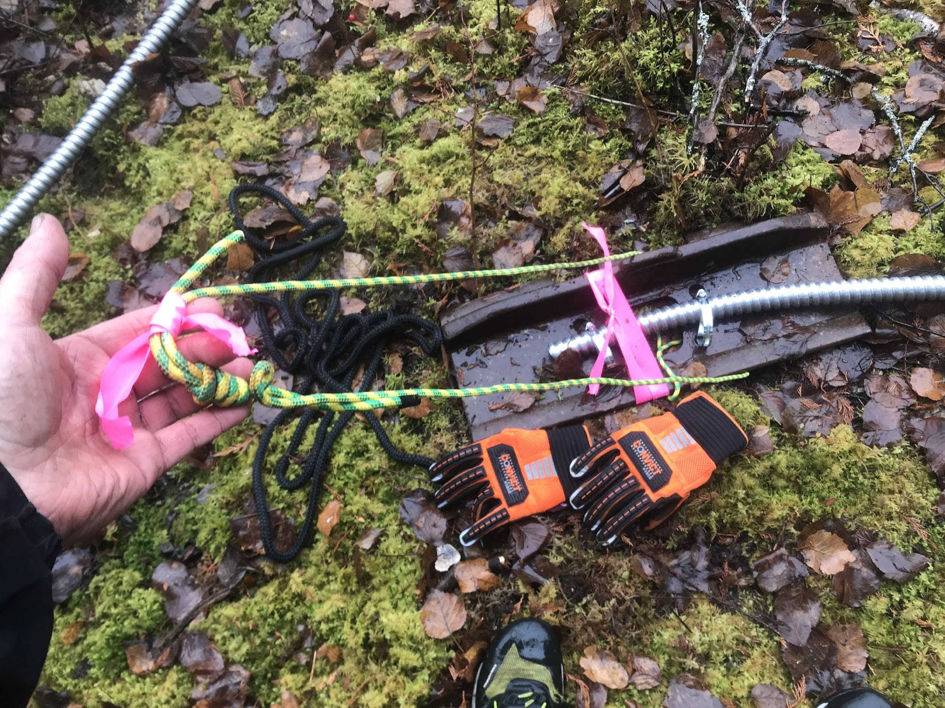
Logger sensor ends of system secured to heavy (~50lb) steel skidder plate with hose clamps with a handle attached to the skidder plate to allow for lowering into place in stream/lake and for easier retrieval when needed.
Logger sensor ends wrapped in duct tape so to ensure a friction fit so logger stays flush with end of electrical conduit.
Connection port end of systems connected to the appropriate optical adaptor to allow for downloading in the field using a mobile device without having to physically retrieve the dataloggers. Connection end of logger connected to 1.5” diameter metal pipe with a Solinst Well Head cap secured to the top for protection from the elements and ease of access to connection port. The well head end then is secured to a tree or a boulder, depending on the site. | 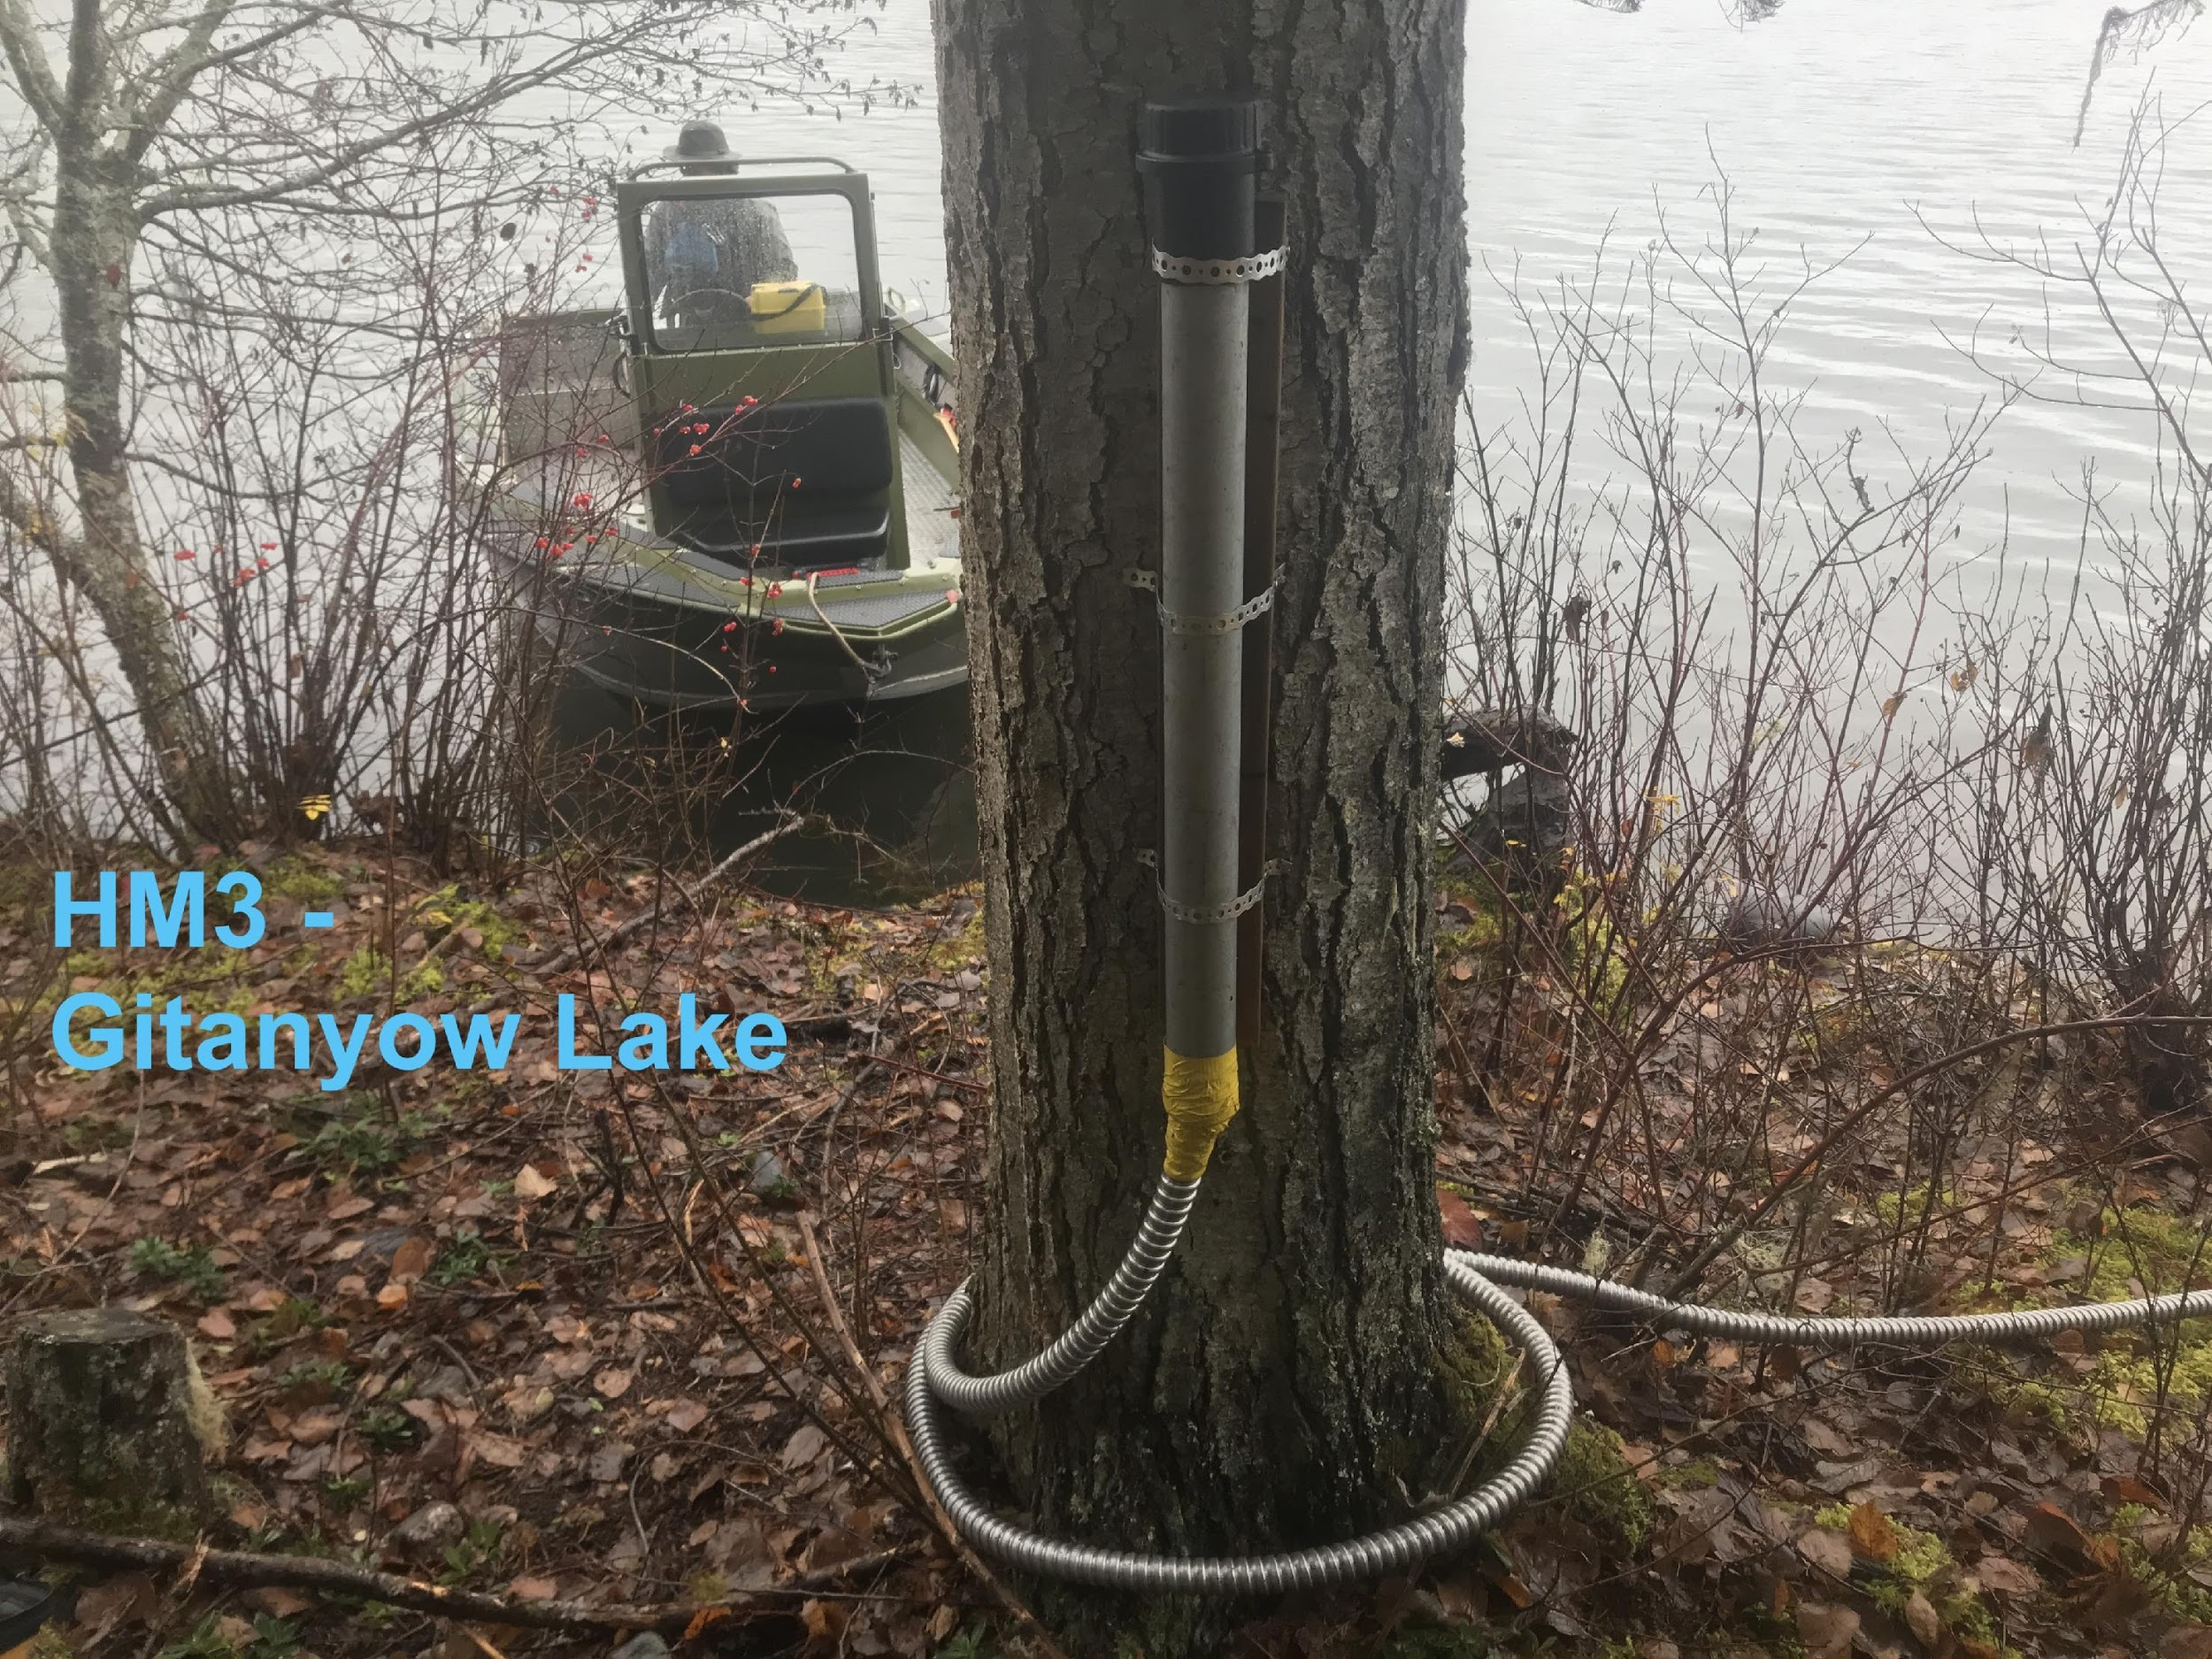  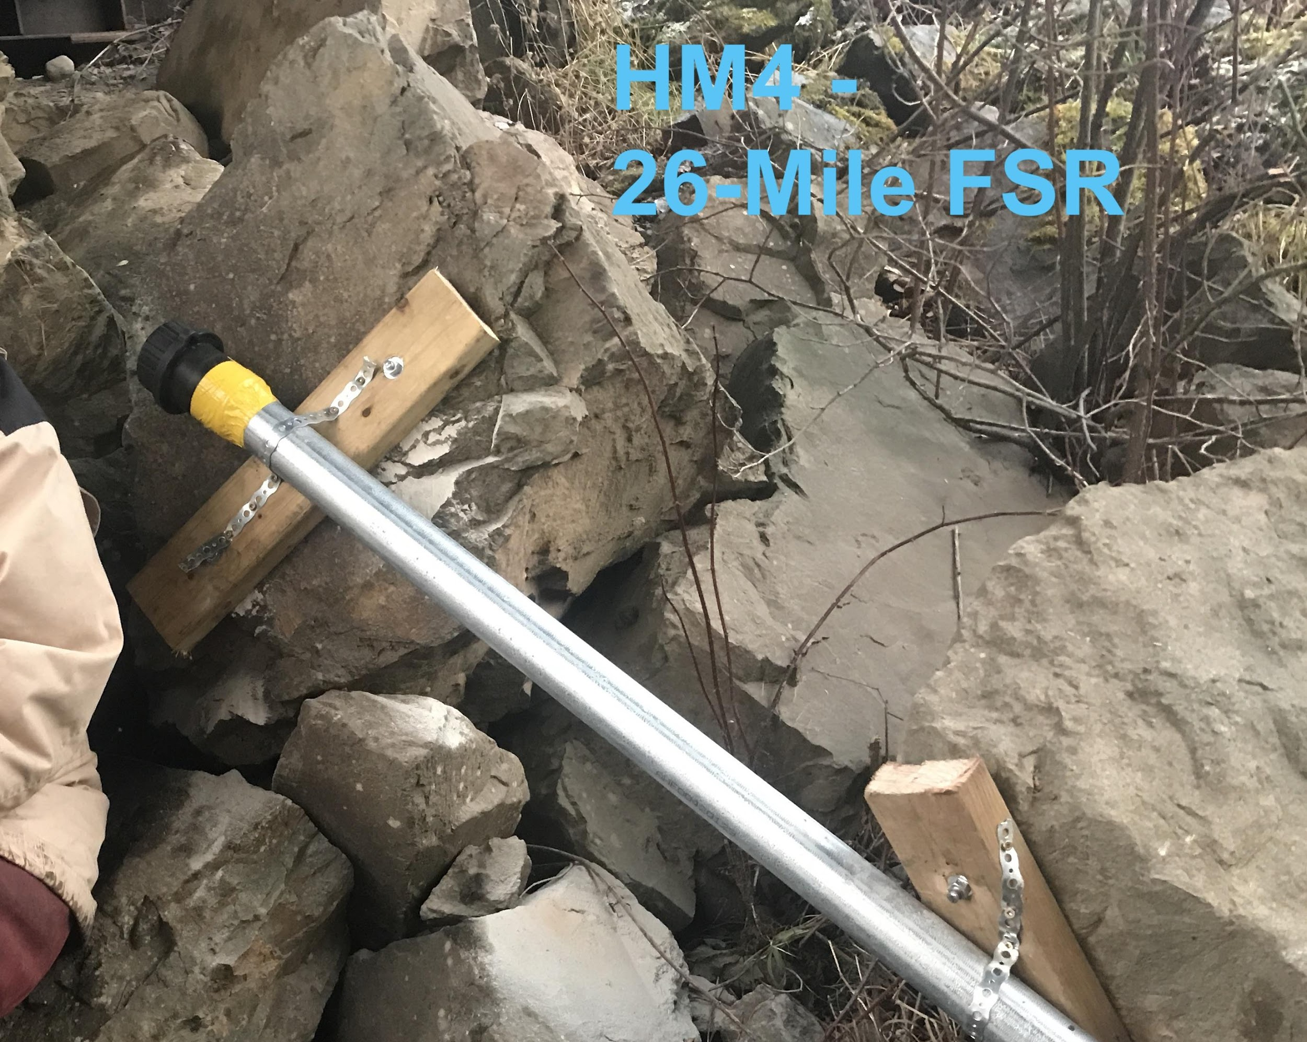  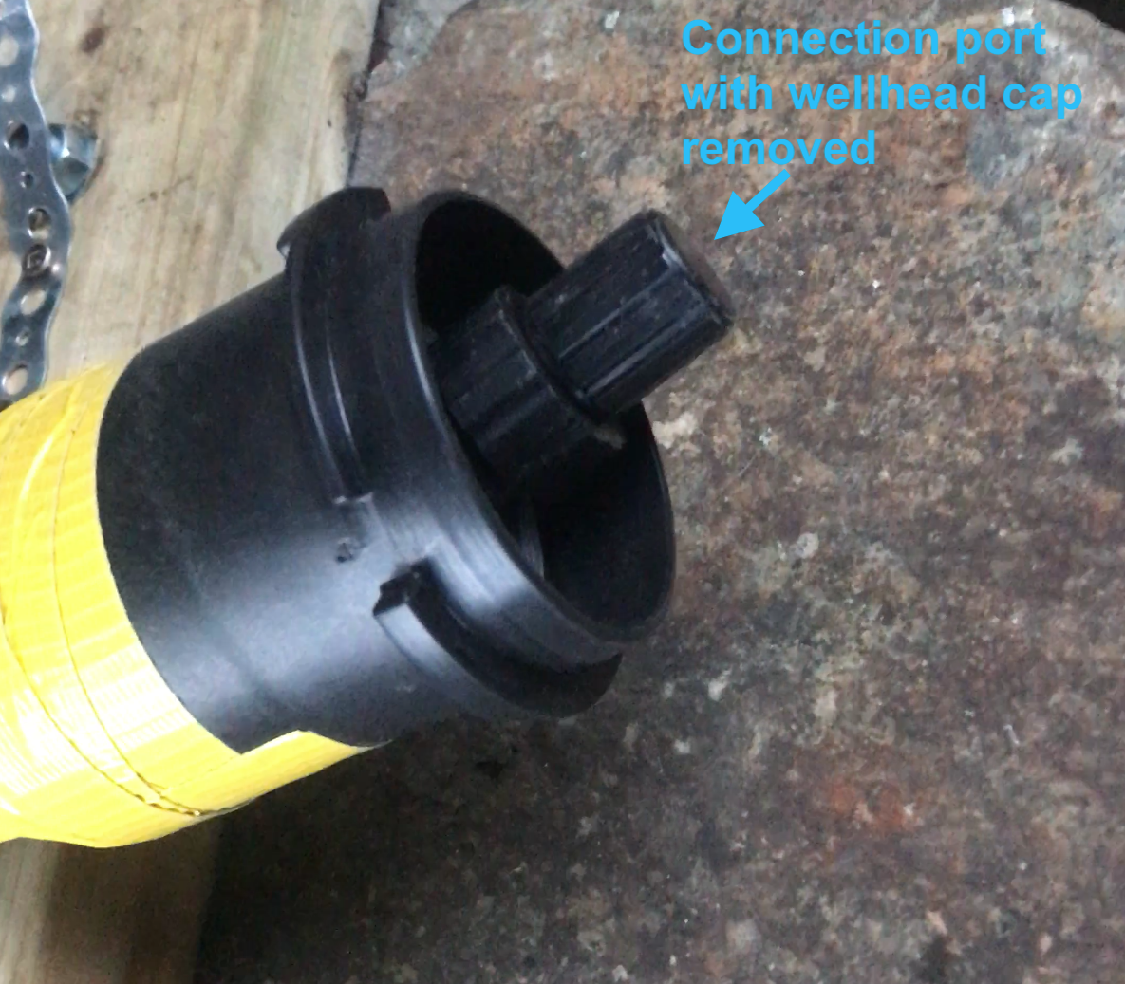
 | 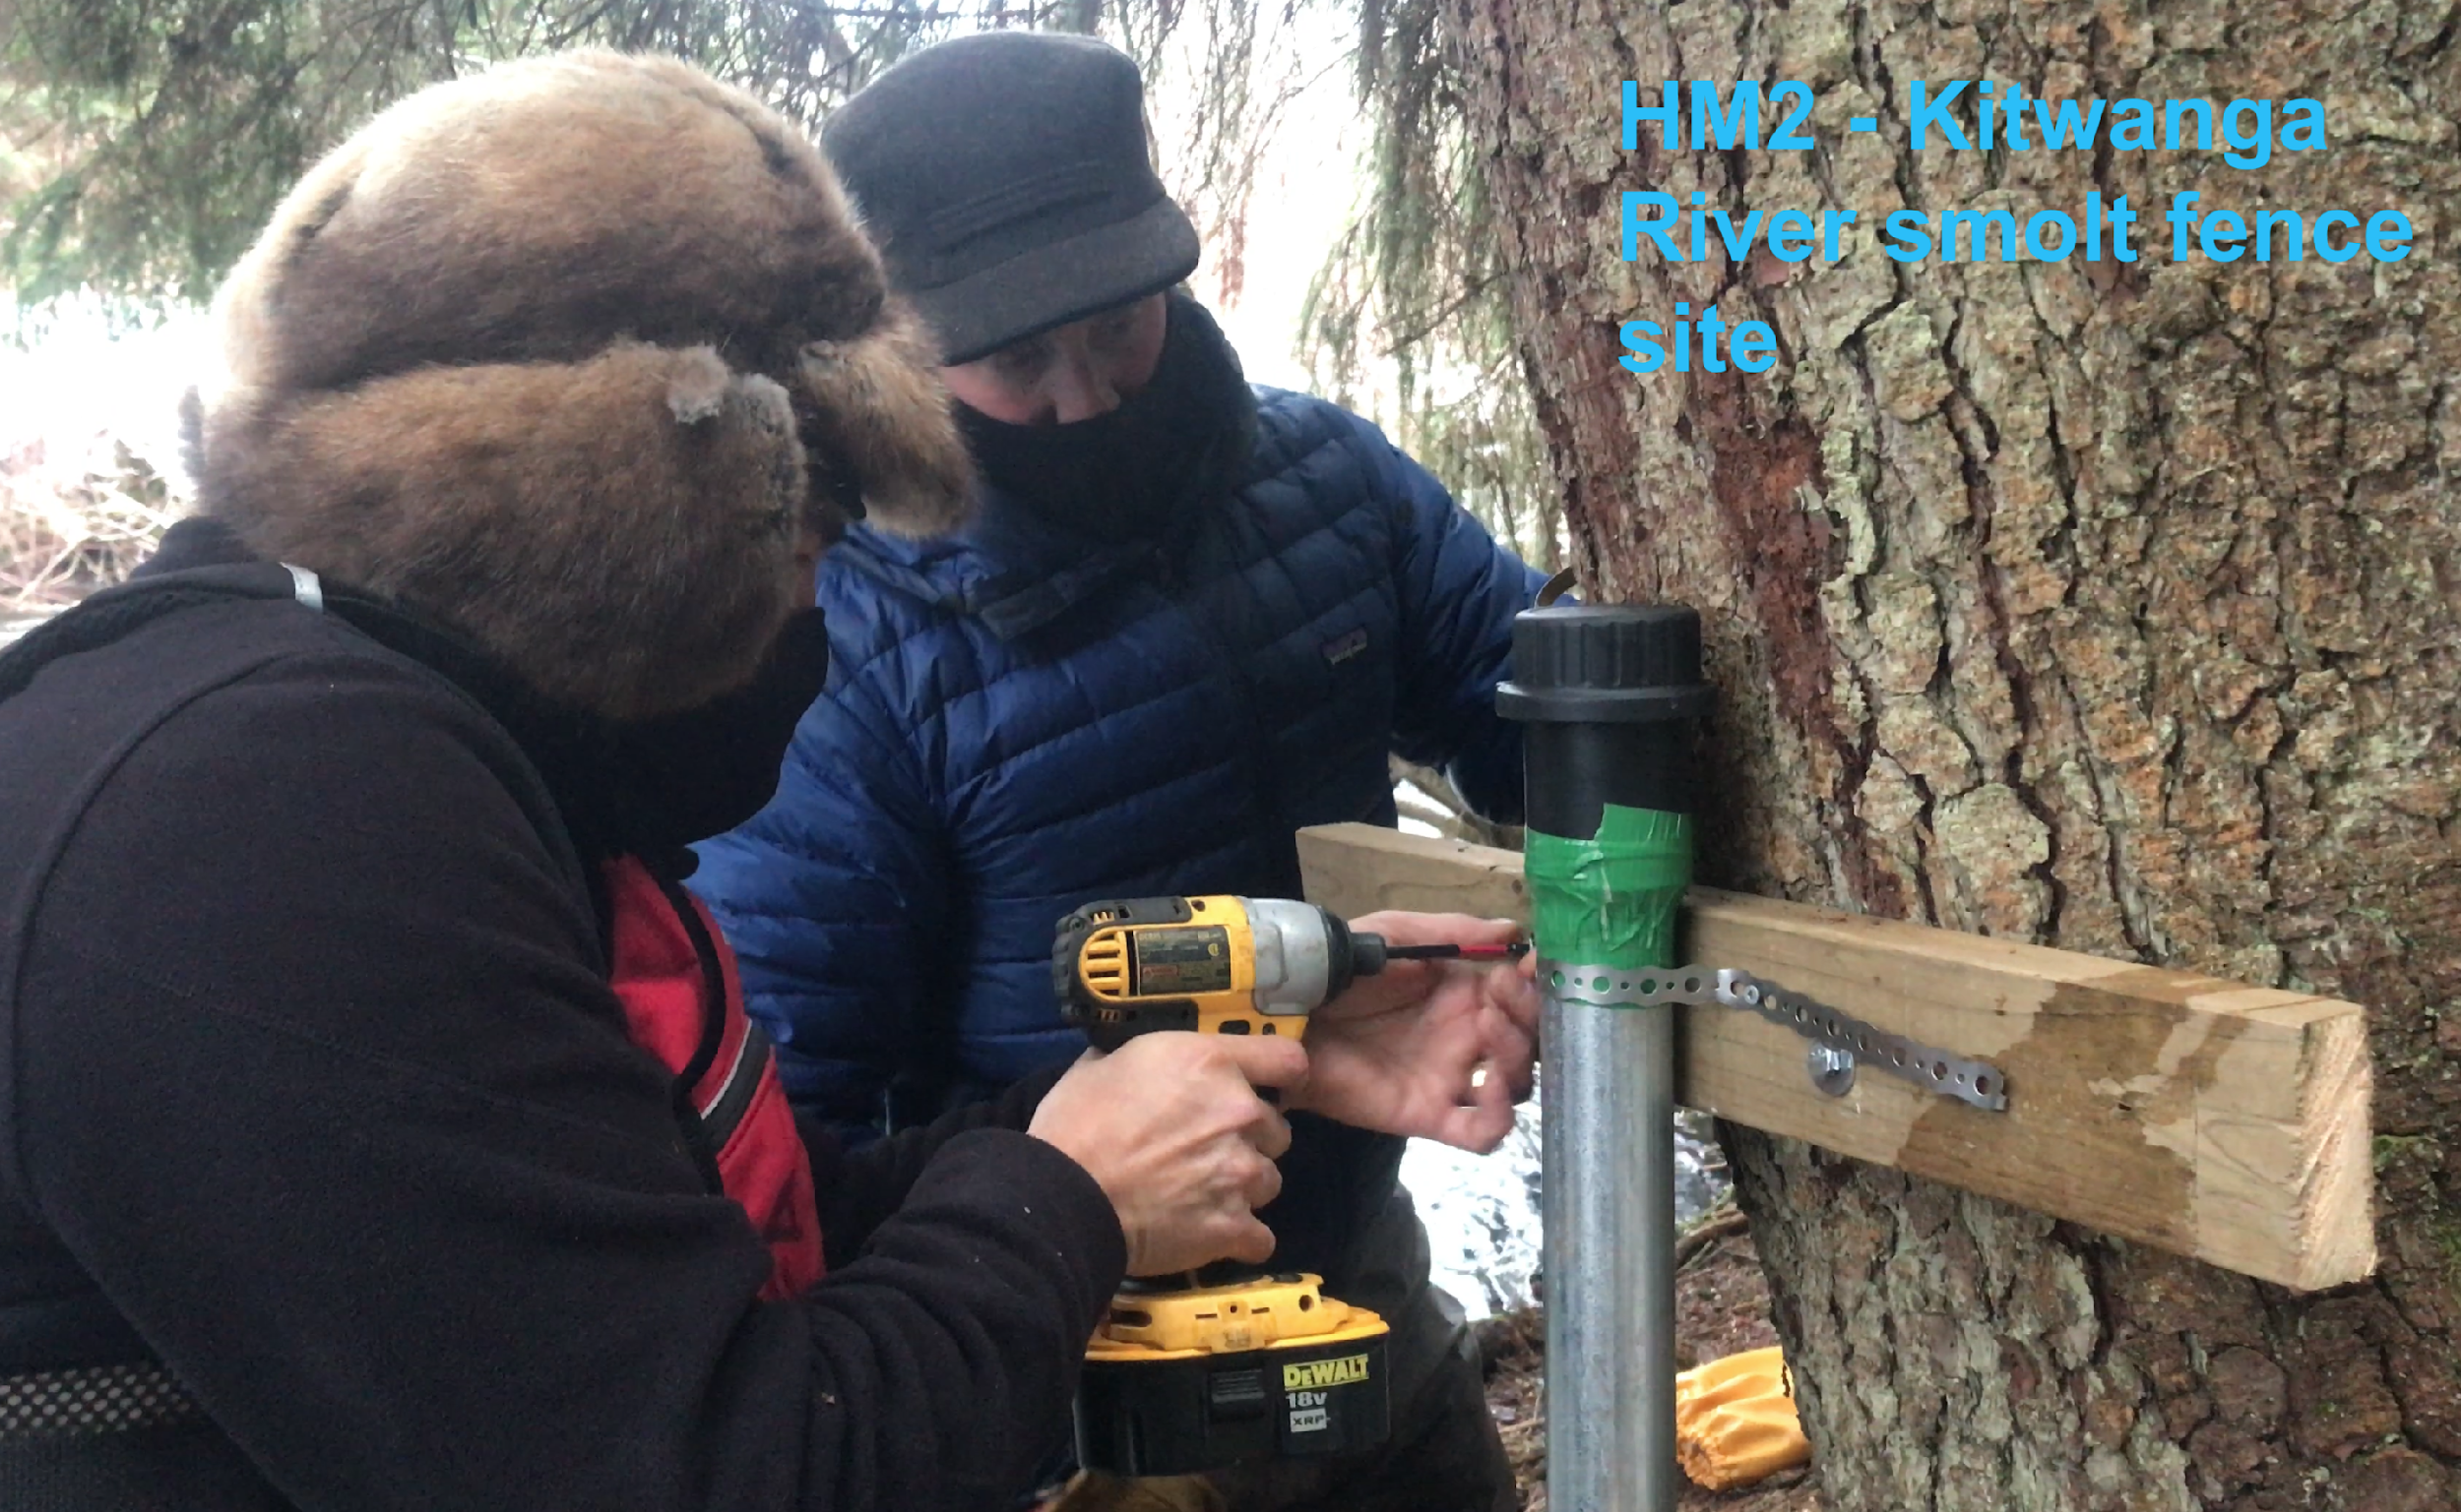
At HM2 (26-Mile site) we installed a manual staff gauge but did not for the others. The manual gauge is optional. | 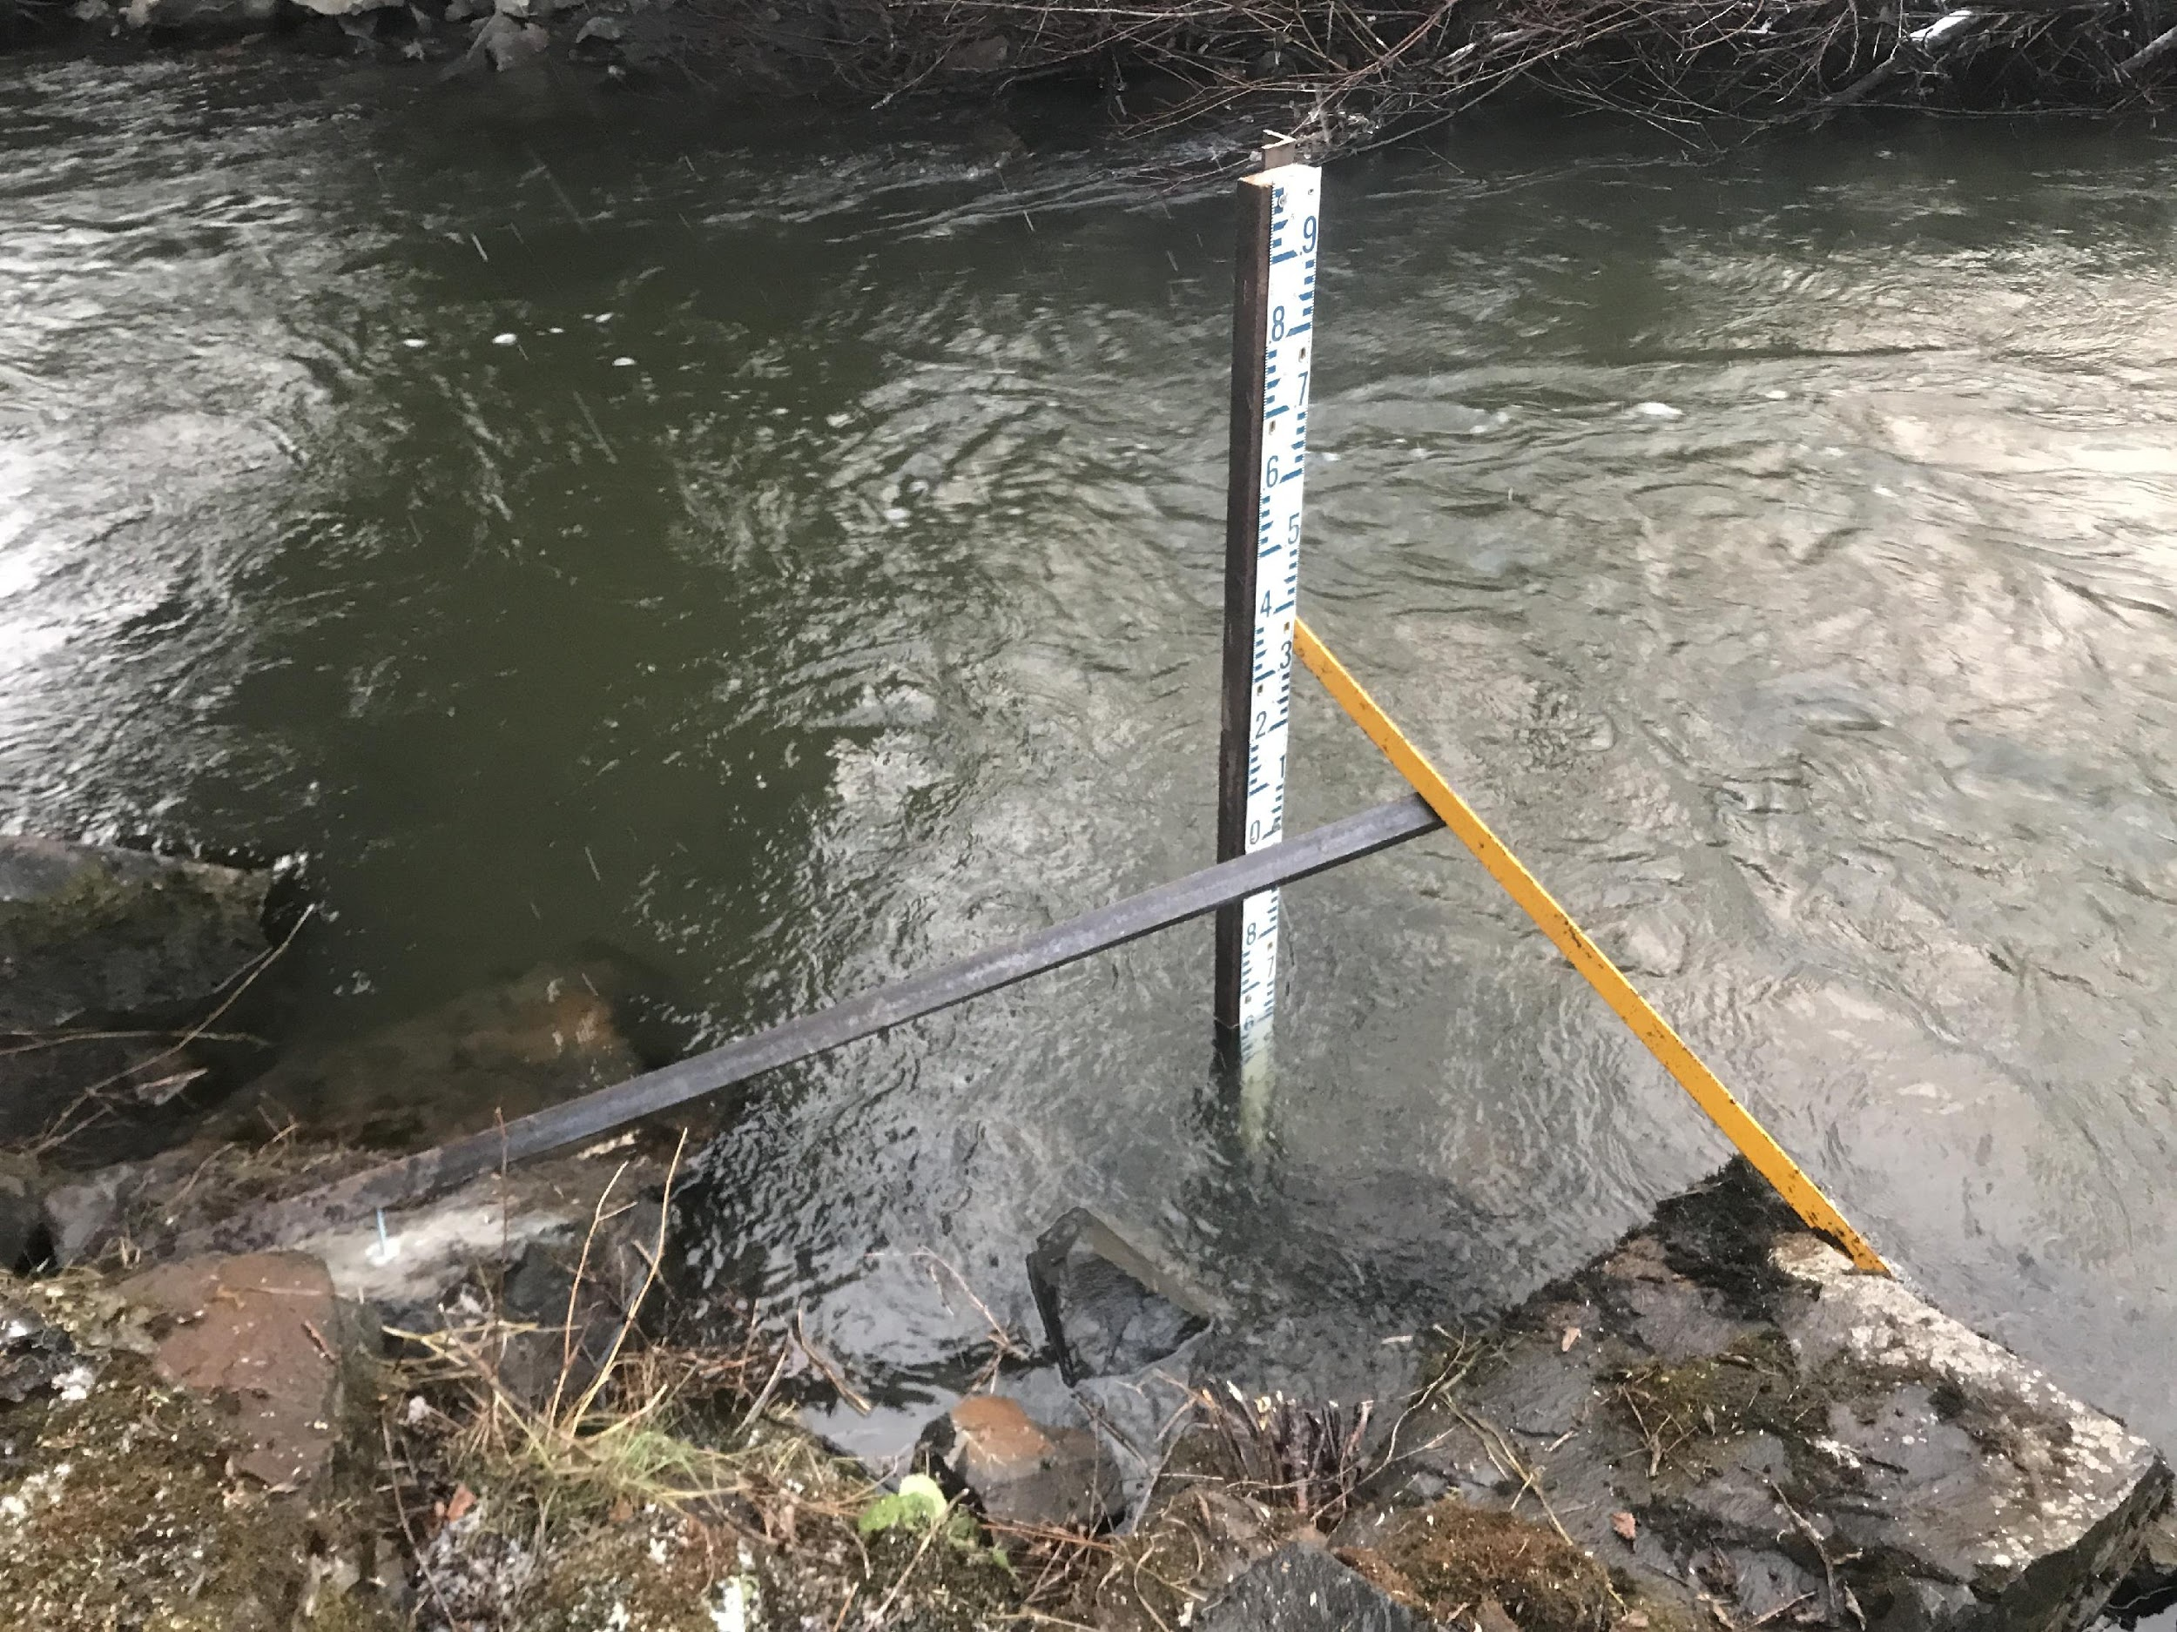

2020 Tidbit Datalogger Installations
The strategy for installation of the Tidbit loggers followed on the objective of the installations which was to conduct intensive temperature monitoring of the primary Kitwanga Lake inflow streams. The locations of Tidbit installations are intended to monitor temperatures in the major inlet streams with roughly equal representation of eastern and western draining systems. The largest streams are targeted for Tidbit monitoring and installation of the 10 units will take place in spring 2021 follow ice-off (Figure 2). One anomolous Tidbit installation will be in Moonlit Creek which enters the left bank of the Kitwanga River downstream of Gitanyow Lake, therefore it does not affect the temperature of Gitanyow Lake. However, it is known as a cool water input to the river and is considered a very important watershed for temperature moderation in the Kitwanga River as well as for spawning coho salmon and other salmonids.

The intended method for the majority of the installations is to attached the Tidbits to a 5-10lb weight using a zapstrap or wire, then attaching the weight to 3/16” airline cable. The weights with Tidbits attached will be placed in deep pool habitat to avoid freezing in winter and the cable will be secured to trees if available or pounded cedar posts. All sites will be heavily flagged to ensure ease of finding in the future.

Table 3: Intended Tidbit installation locations for spring 2021.
Local ID/Map label | UTM Zone | UTM E | UTM N | Location description*
TB1 | 9U | 544420 | 6136379 | 26-Mile FSR to 11km then NW on spur for 0.25km to bridge
TB2 | 9U | 550755 | 6141259 | 26-Mile FSR to 1.5km then Weber FSR to 1.3km
TB3 | 9U | 552527 | 6140744 | 26-Mile FSR to 1km then south on Kitwancool FSR for 100m
TB4 | 9U | 553477 | 6138418 | 26-Mile FSR to 1km then south on Kitwancool FSR for 2.8km
TB5 | 9U | 555190 | 6135874 | 26-Mile FSR to 1km then south on Kitwancool FSR for 5.9km
TB6 | 9U | 555332 | 6133736 | 26-Mile FSR to 1km then south on Kitwancool FSR for 8.2km
TB7 | 9U | 557744 | 6131136 | 9.6km north from Gitanyow south access to Moonlit Creek rest area then downstream to Hwy bridge
TB8 | 9U | 557264 | 6134637 | 13km north from Gitanyow south access road to creek crossing on Hwy 37
TB9 | 9U | 557017 | 6137422 | 15.9km north from Gitanyow south access road to creek crossing on Hwy 38
TB10 | 9U | 555263 | 6139419 | 18.6km north from Gitanyow south access road to creek crossing on Hwy 38
*Note these tidbits have not been installed yet and locations may change depending on conditions found in the field.

The TidBit loggers installed are specifically TidBit V2 Submersible Temperature Loggers with a 42000 measurement memory, 12 Bit resolution, infrared communication and waterproof housing. Their temperature range is -20degC to 30degC. They are set at 15 minute intervals therefore will record data for ~290 days from launch but as with our hydrometric stations, we strive to download a minimum of twice per year.

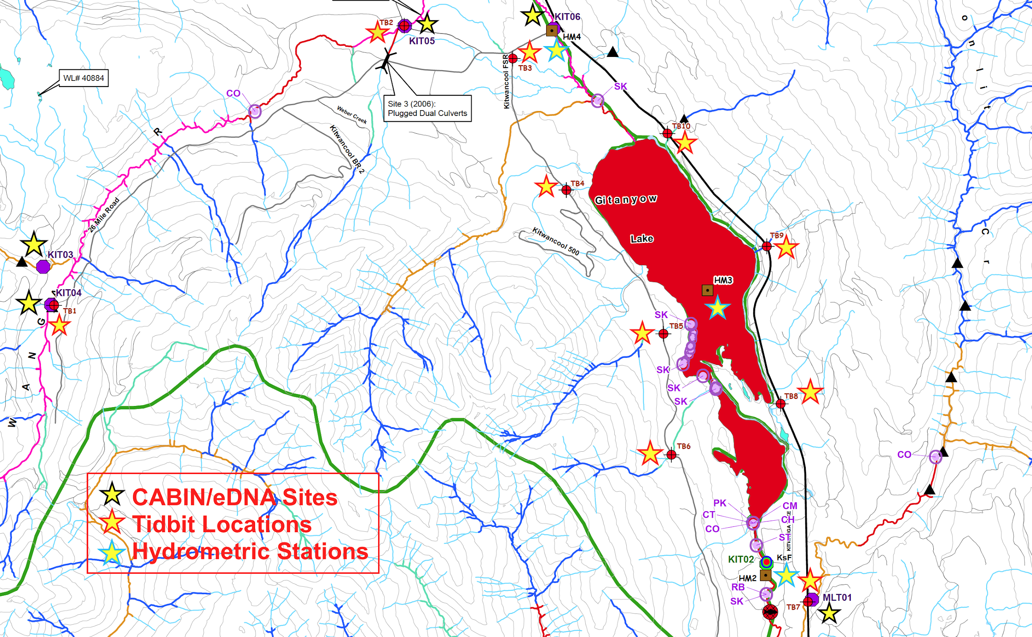
Figure 2: CABIN/eDNA sites, Tidbit installation locations and new hydrometric station locations - Kitwanga River Watershed (2020-21).

2020 FREP-ESI Wetland Assessments
Wetland assessments were not prioritized for 2020 due to several reasons:

- Additional training was required to complete the ESI Wetland Assessment protocol and because of the Covid pandemic, training was delayed until near the end of the wetland sampling window.
- The wetland protocol was not deemed a priority for addressing the specific issues affecting migration and spawning for salmon in the Kitwanga watershed.

However, one ESI wetland assessment site was completed in the upper Kitwanga watershed as part of the training program:

- Wetland ID – 40884 (UTM 09U – 544204E, 6140062N).

Methods - Objective 4: Recommendations for Next Steps

The process for recommendations of next steps came through informal discussions through project team partners, both in the field and following the field season.

Results and Discussion

Objective 1: Socio-Cultural Assessment

First Nations Traditional Use
The Gitanyow and Gitwangak are two Gitksan Nations that have inhabited the Kitwanga Watershed for milenia. More specifically, two Gitwangak Wilps (House groups) Gaxsbgabaxs and Sakxum Higookw inhabit the lower portion of the drainage and Gitanyow Wilps of Gwaas Hlaam and Gwinuu inhabited the middle and upper part of the watershed. Very little was found in the historical literature on Gitwangak salmon use from the Kitwanga Watershed, likely because they fished mostly on the Skeena River given their close proximity to the river mainstem. The Gitanyow village to the contrary was displaced from the Skeena and is located in the middle of the Kitwanga watershed at Kitwancool Creek (middle of the watershed). The Gitanyow were the only Gitxsan settlement removed from the Skeena or Babine River mainstreams. Its location is along the “grease trail” from the Skeena to the Nass River (Derrick 1978).

The abundant and predictable Kitwanga sockeye salmon stocks provided the Wilps Gwaas Hlaam and Gwinuu with the opportunity to harvest and preserve a large amount of high quality food in a relatively short time period. The dominant sockeye run was their main source of food, as it provided the majority of high-quality dried fish needed to sustain them in any given year, and to produce a trade item. Chinook were also harvested during this time, but to a lesser extent. Coho were also harvested annually and available well into the autumn, providing both fresh fish and fish for drying right into fall freeze up. Rainbow trout, steelhead, bull trout, and Dolly Varden char were also fished in their respective habitats and seasons and mostly when salmon were not available. .

In 2002, archaeologist Dr. Paul Prince from Trent University (Peterborough, Ontario) surveyed the area and found the remnants of a group of fish weirs directly downstream of Gitanyow Lake. With the permission of the Gitanyow Chiefs he proceeded to date the wooden stakes that had been preserved in the river substrate and they were found to date back some 770 years. He went on to find that the presence of these weirs provided direct evidence of an intensive fishing culture that was crucially important to inland people and clearly the economic underpinning of Gitksan (and Gitanyow) culture (Prince, 2002).

Rabnett et.al (2002) also documented the extent of the Gitksan / Gitanyow fisheries on the Kitwanga River pre-European contact in the paper: “Dispersed Traditional Fisheries in the Kitwanga River Watershed”. They outlined a highly organized and complex salmon management system that formed the principle foundation of their traditional economies. Hereditary Chiefs exercised authority for management and decision making at key harvest sites, controlling access and determining how many fish should pass to meet spawning requirements and how many could be harvested for food or trade.

There are also numerous historical governmental records outlining the importance and presence of salmon harvesting facilities on the Kitwanga River by Gitanyow people (Photo 1, Photo 2).

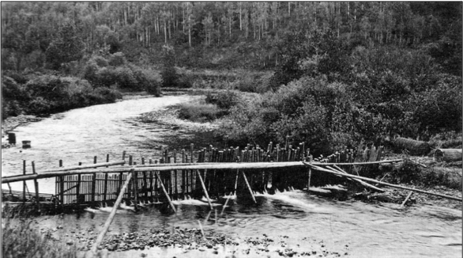
Photo 1: T'in (fishing weir) photographed by federal fisheries inspector Louis Shotridge directly below Gitanyow village in 1918 (courtesy of the Canadian Museum of Civilization, 71-8442).

Fishery inspector Pritchard (1945) reported that: “the Indians do not only catch and cure salmon for their own use, but hoard it up for sale and barter. It is a sort of legal tender amongst them, 10 salmon for a dollar and so many for a blanket”. He went on to say: “it would appear on the basis of tagging experiments that the Indians are able to catch as much as 25% of spawning runs of salmon in some years”. He also reported that between 1935 and 1945 the Indians caught 38,930 sockeye on the Kitwanga system, and that in 1945 there were 92 families with 6 smoke houses living along the Kitwanga River (Cleveland 2000).

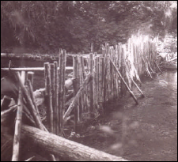
Photo 2: A T'in on the Kitwanga River in 1945, located ~2km downstream of Gitanyow Lake. Federal Research Board of Canada (Rabnett et al., 2002).
Photo SEQ Photo \* ARABIC 2: A T'in (fishing weir) on the Kitwanga River in 1945, located ~2km downstream of Gitanyow Lake. Federal Research Board of Canada (Rabnett et al., 2002).

However, the Gitanyow started to notice significant declines in salmon abundance in the Kitwanga River, especially sockeye. In 1998, interviews were conducted with Gitanyow Elders and oral histories recounted certain years when the salmon did not return, and famines ensued (Jacobs et. al. 1999). The Elders also told that declines in salmon returns began in the 1960’s and that most fishing sites were abandoned along the Kitwanga by the early 1970’s.

Elders indicated that declines in salmon coincided with an increase in industrial logging in the Kitwanga Watershed and increased commercial fishing at the coast. Comments were also made on the increase in Kitwanga Lake summer temperatures, the observed increase of aquatic plants in the lake, and an increase in beaver activity (Jacobs et. al. 1999).

Historical Salmon Abundance
DFO BC16 spawning escapement data (now called nuSEDS) for the Kitwanga River extends back with gaps to 1921. The value of the data lies in the utility of the salmon spawning trends rather than the actual values presented in the records, as most BC16 surveys consisted of single yearly spawning ground observations, which did not allow for accurate determination of adult escapement. Most species were fairly well represented in the BC16 Files for the Kitwanga River during the 1900s, except for sockeye. It becomes apparent early in the DFO records that few estimates of sockeye escapement were made, probably because they did not spawn in the river like the other salmon.

Starting in 2000, Gitanyow Fisheries Authority (GFA) established the Kitwanga River Sockeye Rebuilding Program. This program was developed to determine the factors limiting sockeye production and to restore the stock to historic levels of abundance, however, information on other salmon species is also opportunistically collected. Subsequently, adult salmon escapement data has been collected continuously since 2000 for sockeye through a temporary weir near Gitanyow Lake (2000-2002) and then through the Kitwanga River Adult Salmon Enumeration Facility (KSEF 2003-2020), which collected salmon escapements of not only sockeye, but also Chinook, pink, chum and coho salmon.

The provincial fisheries branch of BC has also operated a steelhead counter (Didson) at the KSEF site since 2013 in partnership with GFA, that program has successfully enumerated adult steelhead in the spring of most years since 2013.

Kitwanga Sockeye

DFO estimates of Kitwanga sockeye escapement maintained between 1919 and 1950 (Smith and Lucop 1966), estimated that escapements were approximately 5,000 to 10,000 spawners annually. According to the historical DFO Escapement records reported since the 1960s, Kitwanga sockeye returns rarely exceeded several hundred spawners, except in 1985 when there were an estimated 2,200 spawners. However, we now know that these earlier estimates of abundance were likely under estimates as Kitwanga sockeye are exclusively lakeshore spawners and spawn at depth where they can not be accurately counted. In most years a small part of the return can be seen spawning on the lakeshore but from years of GFA experience, the number of spawners observed on the spawning beds only represents a fraction of the true returns in a given year. For example in 2010, GFA counted almost 21,000 sockeye through their Kitwanga River adult salmon Enumeration facility but only about 1,500 were observed spawning on the lakeshore (Beblow and Cleveland, 2019).

Traditional Gitanyow Ecological Knowledge of Kitwanga sockeye is well documented and in the early 1900’s sockeye stocks were thriving and Gitanyow Elders spoke of the lakeshores of Gitanyow Lake turning red every fall as the sockeye congregated to spawn on their respective spawning grounds (Figure 4)(Jacobs et. al. 1999). Elders also have oral histories that speak of sockeye spawning in the Lower Kitwanga River directly below the lake and in the Upper Kitwanga River, but this behaviour has not been seen in more recent times (>20 years).

Historical DFO reporting supports some of the Elders accounts, for example:

- In 1929 Fishery Officer G.A. McGrath drew a map showing sockeye spawning locations, where he highlighted most of the north shore and a section along the west bank of the narrows as active spawning sites (DFO BC16 File for 1929).

- In September of 1946 McConnell and Brett visited Gitanyow Lake and gill netted sockeye from the shores of Gitanyow Lake. Their results showed that 10-15% of the adult sockeye caught were spawned-out giving evidence of lacustrine spawning (Photograph #9 & #10, McConnell et. al. 1946).

In 1956 and 1958 Fishery Officer V.H. Giraud wrote “spawning takes place for the most part in the narrows of the lake”, “sockeye use this river to reach Kitwanga Lake but do not spawn in it, spawning in the lake can not be accurately estimated” (DFO-BC16 Files for 1956 & 1958.

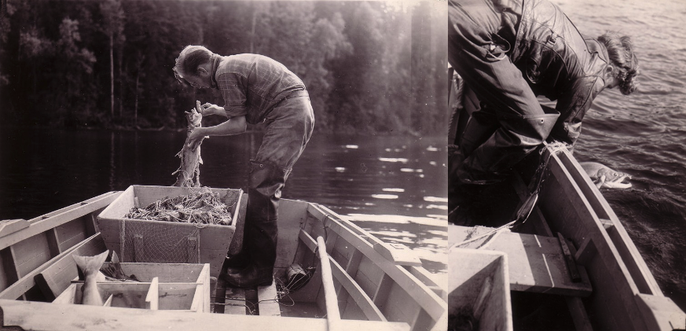
Photo 3: Fisheries officers Fisher (left) removing a dead sockeye from net and McConnell (right) releasing a live sockeye – Gitanyow Lake (1946).

McConnell and Brett from DFO’s Pacific Biological Station spent the summers of 1945 and 1946 studying the Kitwanga River and Gitanyow Lake and during their stay they conducted spot counts of migrating sockeye. In these counts an average of 200 sockeye per day was counted passing a set point between July 24th and August 24th. Based on his observations he estimated that in 1945 the run was probably greater than 6,000. They returned in 1946 and indicated that the sockeye run appeared to be a little bit smaller. This time he estimated it at 4,000 sockeye (McConnell et. al. 1947).

Another example was from a data set found in the DFO archives at the Pacific Biological Station in Nanaimo, BC. The data set came from log books of a fence operation that DFO had installed at the mouth of the Kitwanga River (~1 km from the river confluence with the Skeena) in 1959. The fence was set-up to establish an index count for returning pink salmon. In this data set samplers made specific reference to catching adult sockeye salmon and a total of 4,009 were counted between August 3rd and September 2nd. Because the fence was run for only a portion of the season, the sockeye that were counted would have only represented a portion of the total return. In 2006, GFA used run timing trends collected at the KSEF between 2003-2005 to expand the 1959 run for unaccounted for sockeye and it was estimated that the total run that year would have been approximately 5,000 sockeye, if the run timings and fish migration proportions entering the Kitwanga River were similar.

Other more recent works conducted by p.H. D. candidate Micheal Price at Simon Fraser University reconstructed annual historical (1913–1947) abundance of Kitwanga sockeye in a multi-step process that first involved aggregate estimates of abundance derived from catch (Argue & Shepard 2005) and exploitation (Shepard & Withler 1958), followed by: (1) multiplying annual Skeena aggregate abundance by weekly abundance proportions -randomly drawn from one of seven (2011–2017) years of aggregate run-time data estimated at the Skeena Tyee Test Fishery; (2) multiplying weekly abundance estimates (Step 1) by the proportions of individual Skeena-origin populations in those fishing weeks, then summed across weeks for each population; and (3) repeating steps 1-2 50,000 times to derive a median abundance estimate for each population for each historical year (Price et al. 2019, 2021). Abundance of Kitwanga sockeye ranged from 7,478 (1947) to 117,000 (1937), and averaged 34,423 over the historical time series.

Adult sockeye escapement data has been collected continuously by GFA on the Kitwanga River since 2000 through the operations of a temporary weir (2000-2002) and then through the operations of the Kitwanga River Adult Salmon Enumeration Facility (KSEF 2003-2020). Escapement for over the last decade have been widely variable with the lowest escapement observed in 2019 of only 125 adults and highest in 2010 of 20,804 adults. The average return for the time period is 3,236 adults. More detailed escapement information by year is presented below:

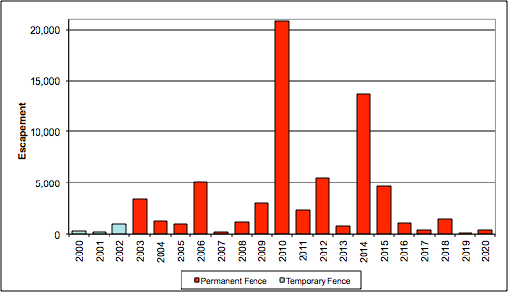
Figure 2: Annual sockeye salmon escapement into the Kitwanga River from 2003 to 2020.

Smolt production from Gitanyow Lake has been accurately assessed continuously since 2008, when the Kitwanga River Smolt Facility (KsF) was constructed. In 2020, the Kitwanga Sockeye Salmon Recovery Plan was updated to compile and summarize the data collected and the rebuilding efforts conducted by GFA and DFO since 2006 (KSRP - 2020). The goal of the KSRP-2020 is to confirm and prioritize current monitoring works and to develop and prioritize a new direction as deemed necessary to recover Kitwanga sockeye to more historical levels.

In conjunction with counting fences, GFA has conducted lakeshore spawning assessments, habitat rehabilitation works, egg-to-fry survival studies and limnological assessments on Gitanyow Lake. In an effort to boost egg-to-fry survival, a two-year small-scale pilot hatchery program was also conducted in 2006/07 and in 2007/08 (Cleveland 2007 & 2009, Kingston 2008 & 2009, McCarthy and Cleveland 2012). In addition, an overall reduction in the exploitation rate (ER) on adult Kitwanga sockeye has been implemented since 2009 in most years, where averages ER have been reduced to about 20%.

Kitwanga sockeye are an evolutionary significant unit as defined in Canada’s Wild Salmon Policy because they have developed specific life history adaptations and timing regimes that are genetically unique. They are unique because there is little possibility that neighbouring sockeye populations could replace them naturally, given the extremely limited gene flow, geographical separation between populations and the degree of local adaptations.

There has only been one recent account of sockeye river spawning in the Kitwanga and that was observed by NewGen Resource Consultant. According to NewGen, 192 sockeye were observed spawning downstream of the lake outlet on October 5, 1998 (Jacobs et. al. 1999). From 1999 to 2005 the GFA have been actively seeking out sockeye spawning areas in the Kitwanga Watershed. To date sockeye have been observed spawning along the western shoreline of Gitanyow Lake near the narrows in 1999 and 2002 through 2005 (Photograph #11). All observed spawning activity can be described as “light” meaning redds and or sockeye have only been found at the sites in low densities, usually representing less than 25% of any given years run. No sockeye river spawners have been observed since 1998.

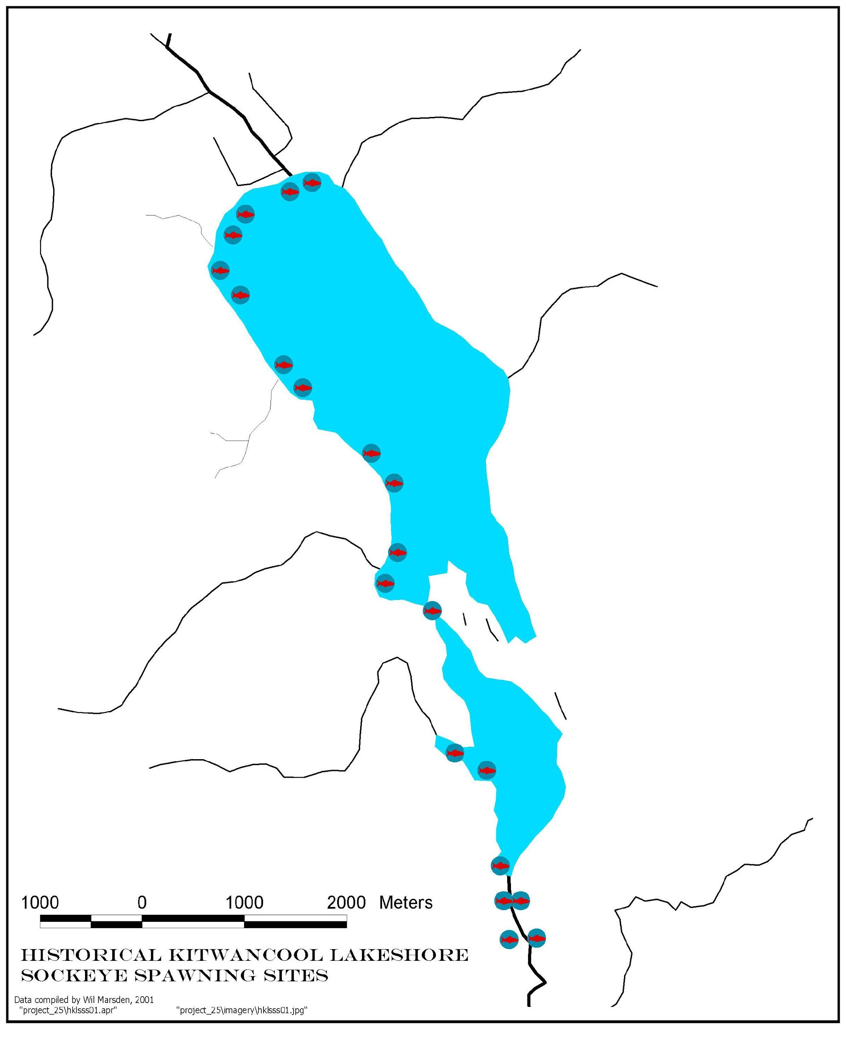
Figure 3: Map of historical Kitwanga sockeye spawning locations.

Kitwanga Chinook

Kitwanga Coho

Kitwanga Steelhead

Objective 2: Data Compilation

Kitwanga River watershed habitat and salmonid assessment related documents were compiled into folders by year, from 2006 to 2020. Key stream reach, habitat, monitoring and salmonid spawning spatial information were compiled onto a 1:30,000 scale map (Appendix A). All files are loaded onto a Sync drive folder within the ESI Fish and Fish Habitat Tier Two sampling that will be accessible to FLNRORD and other BC staff. This data collaboration and established location will enable ongoing data sharing between Gitanyow and FLNRORD staff. The link to the Sync drive folder is:

https://ln.sync.com/dl/f16d0acf0#v2c9qa55-aqj78djt-3354n6rw-88ydze5w

Objective 3: Ground Based Technical Assessment

CABIN-eDNA Sampling
Five CABIN-eDNA sites were completed in 2020 in the Kitwanga River watershed (Table 4, Figure 2) between November 12 and 17, 2020. Water quality sampling was conducted and samples were shipped to ALS Labs Burnaby, BC. Macroinvertebrate samples were sent to Guelph University for eDNA analysis. Results from the eDNA analysis are still forthcoming and expected in May, 2021 and will be loaded onto the Sync drive once available.

There are now a total of seven CABIN-eDNA sites in the Kitwanga watershed, five of which are impact sites and two which are considered reference sites. Because of extensive forest harvesting in the Kitwanga watershed it is difficult to find true reference conditions for comparison.
Table 4: 2020 CABIN-eDNA sites completed in the Kitwanga River watershed.
Site # / Map Label | Creek/River Sampled | Sampling date | Road Name | UTM Zone | Easting | Northing | Reference / Impact Site?
KIT03 | Unnamed trib to Kitwanga River | 12-Nov | 26-Mile FSR road network | 09U | 544299 | 6137086 | Reference
KIT04 | Upper Kitwanga River mainstem | 12-Nov | 26-Mile FSR road network | 09U | 544371 | 6136387 | Reference
KIT05 | Upper Kitwanga River mainstem | 14-Nov | Weber FSR | 09U | 552775 | 6141026 | Impact
KIT06 | Upper Kitwanga River mainstem | 17-Nov | 26-Mile FSR | 09U | 553247 | 6141247 | Impact
MLT01 | Moonlit Creek | 14-Nov | Hwy 37N | 09U | 557817 | 6131174 | Impact

Results from the seven CABIN-eDNA sites will form part of a baseline for water quality, biological integrity and stream health. They will be incorporated into a broader Water Planning and Policy process currently underway on the Gitanyow Lax’yip. As both natural and anthropogenic restoration and activities occur in the Kitwanga Watershed these data will be available for comparison to understand changes in coming years and decades.

Wetland Sampling
One ESI wetland site was completed in 2020. The data from this site will be incorporated into a broader ESI report to be produced in 2021. The intent is that if funding comes in early in 2021 this will allow more wetlands to be assessed.

Hydrometric Station Development and Tidbit Installations
Three new stations were installed as described above. No data has been downloaded yet as these were installed later in the fall of 2020.

Objective 4: Recommendations for Next Steps

- Enter CABIN data into the CABIN database as part of 2021 programming.
- Review and discuss eDNA results and incorporate findings into future strategic assessment planning.
- Future CABIN-eDNA sampling should focus on finding more reference sites, ideally in the upper Moonlit Creek watershed.
- Kitwancool, Deuce and Tea Creeks are also important watersheds for CABIN-eDNA sampling should funding become available.
- Seek funding for maintenance of the three new hydrometric stations in the upper Kitwanga Watershed, including regular downloads and at least 8-12 discharge measurements for HM2 and HM4. Produce stage-discharge curve by end of 2021 field season.
- Complete installation of 10 Tidbit loggers at locations described above and conduct regular (every two months) downloading. Produce temperature graphs. Incorporate temperature data with that obtained from HM1 through HM4 and with other temperature data being gathered through the broader Kitwanga Sockeye Recover Program limnological studies.
- Compile the oldest possible historical air photos for the upper Kitwanga watershed wetland complex and the mainstem between the Gitanyow Lake outlet and Moonlit Creek. Stitch these images together to produce a georeferenced photo-mosaic.
- Seek funding to fly these same areas with a drone to re-create the photo-mosaics for comparison.
- Compile this additional information to present to the broader Kitwanga Sockeye Recovery Planning committee to determine what the most appropriate next potential restoration steps are.

References

Beblow, J. and M.C. Cleveland. 2019. Kitwanga River Salmon Enumeration Facility (KSEF) – 2018
Annual Report. Prepared for the Gitanyow Hereditary Chiefs, the Department of Fisheries and Oceans Canada and the Pacific Salmon Commission. Gitanyow Fisheries Authority. Kitwanga, BC. V0J2A0. 38pp.

Cleveland, M.C. 2000. Limnology of Kitwanga Lake: an attempt to identify limiting factors affecting
sockeye salmon (Oncorhynchus nerka) production. Gitanyow Fisheries Authority, Kitwanga, B.C. 97 pp.

Jacobs, M. and T. Jones. 1999. Kitwanga River Salmon Recovery Initiative 1998. NewGen Resources
Consulting. New Hazelton, BC. 45pp.

Price, M.H.H., B.M. Connors, J.R. Candy, B. McIntosh, T.D. Beacham, J.W. Moore, and J.D. Reynolds.
2019. Genetics of century-old fish scales reveal population patterns of decline. Conservation Letters, 12(6), e12669. https://doi.org/10.1111/conl.12669.

Price, M.H.H., J.W. Moore, B.M. Connors, K.L. Wilson, and J.D. Reynolds. 2021. Portfolio simplification
arising from a century of change in population diversity and artificial production. Journal of Applied Ecology (in press).

Prince, P. 2005. Fish Weirs, Salmon Productivity, and Village Settlement in an Upper Skeena
Tributary, British Columbia. Can. Journal of Archaeology. 29pp.

Rabnett, K., A. Gottesfeld and C. Holland. 2002. Dispersed Traditional Fisheries in the Kitwanga
River Watershed. Gitxsan Watershed Authorites. Hazelton, BC. 26pp.

Shepard, M.P. and F.C. Withler. 1958. Spawning stock size and resultant production for Skeena
sockeye. Journal of the Fisheries Research Board of Canada, 15, 1007–1025.
https://doi.org/10.1139/f58-055.

